Anthology
Student Self-Service Admissions: Build a FERPA Process Using Forms Builder and Workflow

Anthology

Web Site
www.campusmanagement.com

Contact Information
Phone: 1.561.923.2500
Sales/Support: 1.561.999.9904
Toll Free: 1.800.483.9106
Facsimile: 1.561.999.0096

Address
Campus Management Corp.
5201 Congress Ave
Boca Raton, FL 33487 USA

Copyright
© 2019 Campus Management Corp. All rights reserved. Campus Management Corp. and the Campus Management logo are trademarks or service marks of Campus Management Corp. These marks may be registered in the U.S. or other countries. All other registered trademarks and service marks are the properties of their respective owners.

Contents
Resources 1
Angular JS 1
Understanding OData 3
Validation Regex property in Forms Builder 3
Log File Location & Names 3
Agenda 4
Introduction 5
Course Objectives 5
Target Audience 5
Course Prerequisites 5
Lesson 1: Create a Student Self-Service Form and Supporting Workflow 6
Exercise: Create a FERPA Form and Supporting Workflow 6
Lesson 2: Validate the Form and Supporting Workflow 76
Exercise: Validate the Student Self-Service Form and Supporting Workflow for the FERPA Process 76

Angular JS
https://docs.angularjs.org/guide/introduction:
AngularJS is a structural framework for dynamic web apps. It lets you use HTML as your template language and lets you extend HTML's syntax to express your application's components clearly and succinctly. AngularJS's data binding and dependency injection eliminate much of the code you would otherwise have to write. In addition, it all happens within the browser, making it an ideal partner with any server technology.
AngularJS is what HTML would have been, had it been designed for applications. HTML is a great declarative language for static documents. It does not contain much in the way of creating applications, and as a result building web applications is an exercise in what do I have to do to trick the browser into doing what I want?
The impedance mismatch between dynamic applications and static documents is often solved with:
- a library - a collection of functions, which are useful when writing web apps. Your code is in charge and it calls into the library when it sees fit. E.g., jQuery.
- frameworks - a particular implementation of a web application, where your code fills in the details. The framework is in charge and it calls into your code when it needs something app specific. E.g., durandal, ember, etc.
AngularJS takes another approach. It attempts to minimize the impedance mismatch between document centric HTML and what an application needs by creating new HTML constructs. AngularJS teaches the browser new syntax through a construct we call directives. Examples include:
- Data binding, as in {{}}.
- DOM control structures for repeating, showing and hiding DOM fragments.
- Support for forms and form validation.
- Attaching new behavior to DOM elements, such as DOM event handling.
- Grouping of HTML into reusable components.

Angular JS Resources
https://www.w3schools.com/js/js_comparisons.asp
https://teropa.info/images/angular_expressions_cheatsheet.pdf

https://docs.angularjs.org/guide/expression

Understanding OData
http://www.odata.org/getting-started/understand-odata-in-6-steps/
OData (Open Data Protocol) is a standard that defines the best practice for building and consuming RESTful APIs. OData helps you focus on your business logic while building RESTful APIs without having to worry about the approaches to define request and response headers, status codes, HTTP methods, URL conventions, media types, payload formats and query options etc. OData also guides you about tracking changes, defining functions/actions for reusable procedures and sending asynchronous/batch requests etc. Additionally, OData provides facility for extension to fulfil any custom needs of your RESTful APIs.
OData RESTful APIs are easy to consume. The OData metadata, a machine-readable description of the data model of the APIs, enables the creation of powerful generic client proxies and tools. Some of them can help you interact with OData even without knowing anything about the protocol.
To learn more about the OData query syntax, see http://www.OData.org/ and look for "Basic Tutorial” and "Advanced Tutorial”.

Validation Regex property in Forms Builder
Validation Regex is the regular expression pattern to validate the input. Use site like http://RegExLib.com to search and test Regex patterns, or construct your own with Regex tools like Expresso. If the user input does not produce a Regex match, the "Validation message" will be displayed.
Examples:
Regex that enforces a minimum of 11 digits for a phone number where the first digit must be "1": 1\d{10}
Regex that enforces a phone number in the format (###)###-####: ^\([0-9]{3}\)[0-9]{3}\-[0-9]{4}$
Regex that matches a hyphen-separated social security number: ^\d{3}-\d{2}-\d{4}$

Log File Location & Names
Log files for Forms Builder are located at:
\\server\c$\logs - (where server is the hostname for your environment)
Look for FormsBuilderRenderer-date.txt & FormsBuilderDesigner-date.txt

Agenda

Time | Topic | Activity
1:00 – 1:45 PM | Course Overview and Introductions
1:15 – 1:30 PM | Student Self-Service FERPA Process Overview | Demo
1:30 – 2:30 PM | Lesson 1: Create a Student Self-Service Form and Supporting Workflow for FERPA Release of Information | Exercise: Create a FERPA Form and Supporting Workflow
2:30 – 2:45 PM | Break
2:45 – 4:00 PM | Lesson 1: Create a Student Self-Service Form and Supporting Workflow for FERPA Release of Information (Continued)
4:00 – 4:30 PM | Lesson 2: Validate the Form and Supporting Workflow | Exercise: Validate the Student Self-Service Form and Supporting Workflow for the FERPA Process

Introduction
This is an advanced, hands-on session. Participants will learn how to build a student self-service FERPA Process using Forms Builder, Workflow, and CampusNexus Student.

Course Objectives
Upon completion of this session, participants will be able to:
- Build a FERPA Form Sequence
- Automate the FERPA Process utilizing Workflow and CampusNexus Student configurations

Target Audience
Technical Business Analysts, System Administrators, Database Programmer, IT staff members

Course Prerequisites
Prerequisite Knowledge:
- Understanding of Business Processes
- Understanding of CampusNexus Student Application and Schema and/or CampusNexus CRM Application and Schema
- Aware of .NET Technologies and Understanding of VB.Net
- Create Variables, Assign Data Types, and a Basic Understanding of Development Languages
- Awareness of:
  - Windows Workflow Foundation (4.5)
  - CSS Themes
- SQL Knowledge
  - Ability to create SQL jobs, call Stored procedures and Write Queries
- General Development Knowledge of Variables, Arguments, Control Logic, Exception Handling, Debugging etc.

Lesson 1: Create a Student Self-Service Form and Supporting Workflow
In this lesson, you will create a FERPA Release of Information process that will allow the student to specify which directory fields he/she wants to release and to whom the information can be released to.

Exercise: Create a FERPA Form and Supporting Workflow

- Navigate to Google Chrome and Launch Designer from the Bookmarks Bar.
- Sign in using the following credentials:
administrator
testing
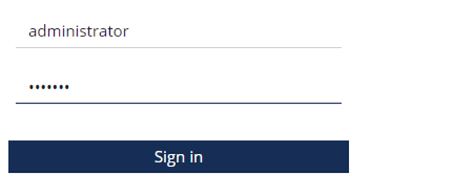

- Select the Form Designer to start creating your form.
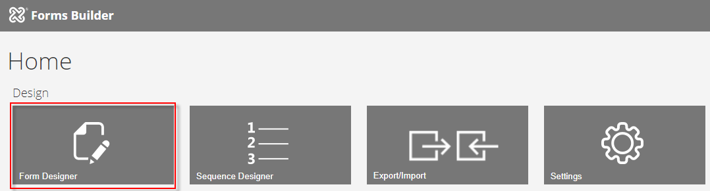

- Select New. A 1 Column panel is added to the Layout pane in the Designer.
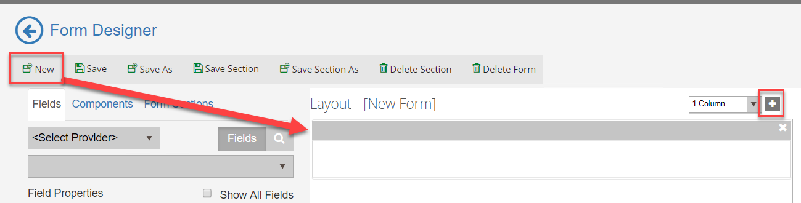

- From the Components tab, drag two HTML components into the panel of the Layout pane.
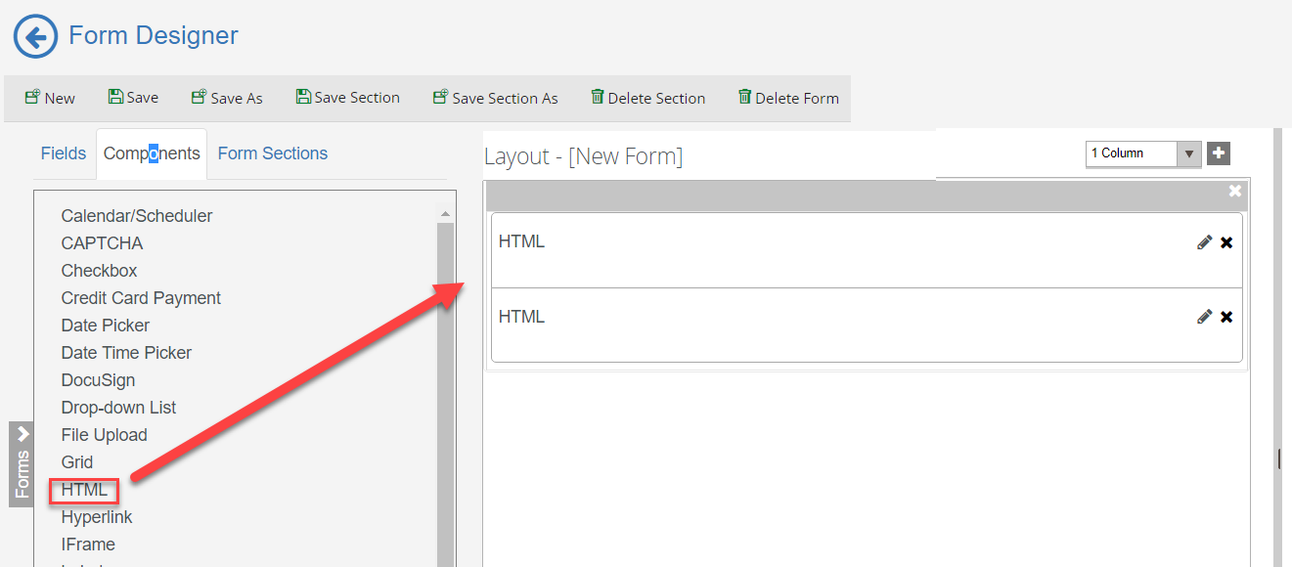

- Enter the following for the first HTML component in the HTML property of the Control Property Settings pane:
<h1>FERPA RELEASE FORM</h1>

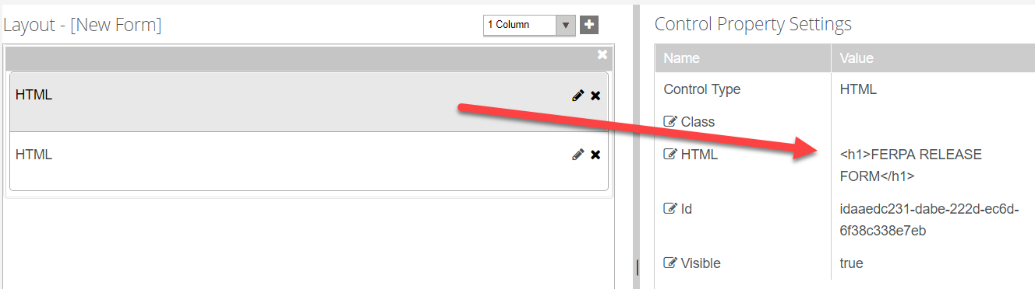

- Enter the following for the second HTML component in the HTML property of the Control Property Settings pane:
<b><i>The Family Educational Rights and Privacy Act of 1974, also known as FERPA and/or The Buckley Amendment of 1974, as amended, grants students and eligible parents certain rights and privacies regarding education records of students attending postsecondary institutions. By submitting this form, the student may consent to release his/her educational records and/or other information to a third-party for a defined purpose. A new form must be submitted for each request.</i></b>
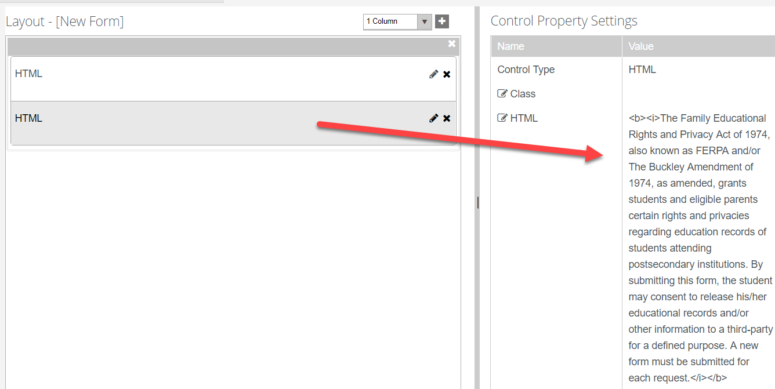

- Click the + and select the column option to add a 3 Column panel to the Layout pane.

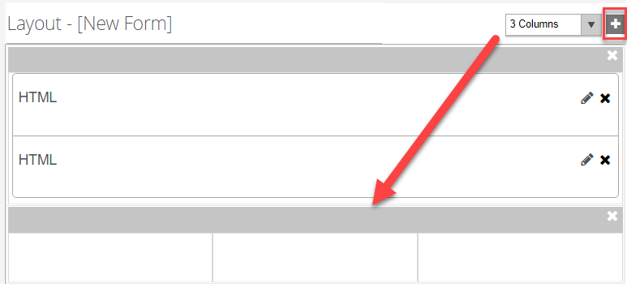

- From the Components tab, drag three HTML components into the panel of the Layout pane.
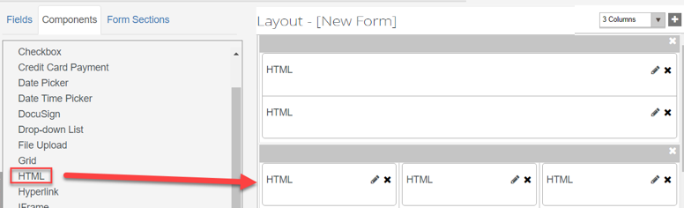

- For the first HTML component, enter the following in the HTML property of the Control Property Settings pane:
<b>Student Information:</b>
Note: The second and third HTML components are used as a place holder so we will not enter anything in the Control Property Settings pane for these components.
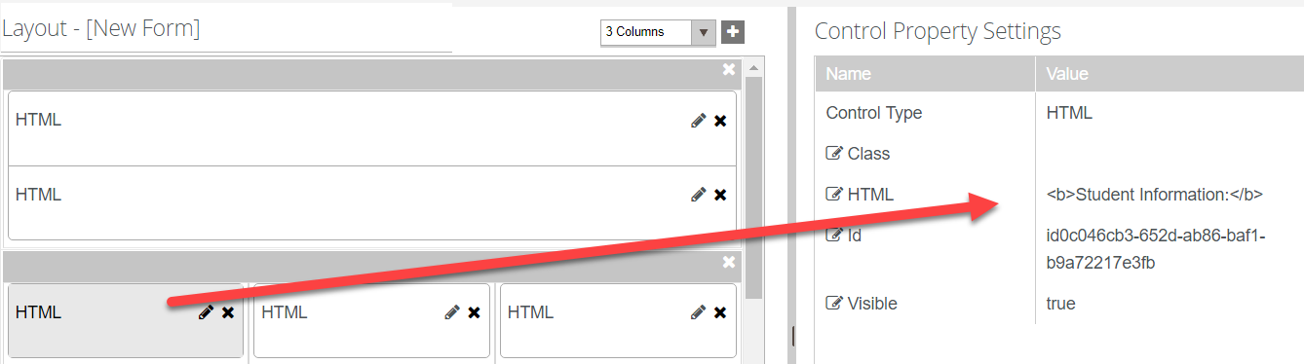

- Select the Fields tab and under Student select the Student entity. Drag the following fields into the second panel below the HTML components as shown below:
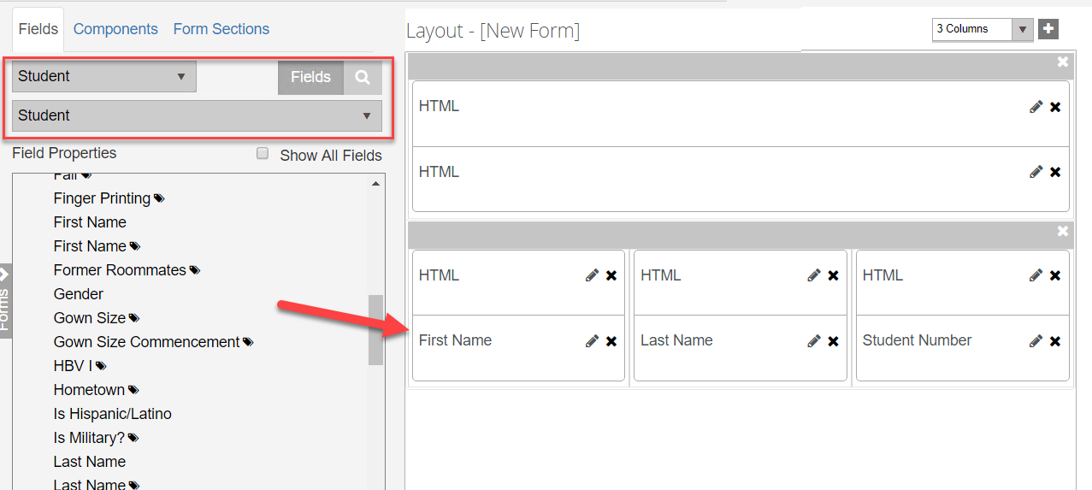
- Make sure the Read-only property in the Control Property Settings pane is set to true for the First Name and Last Name fields.
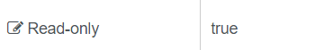

- Make sure the Required property in the Control Property Settings pane is set to false for the First Name and Last Name fields.
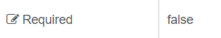

- Click the + and select the column option to add a 1 Column panel to the Layout pane.

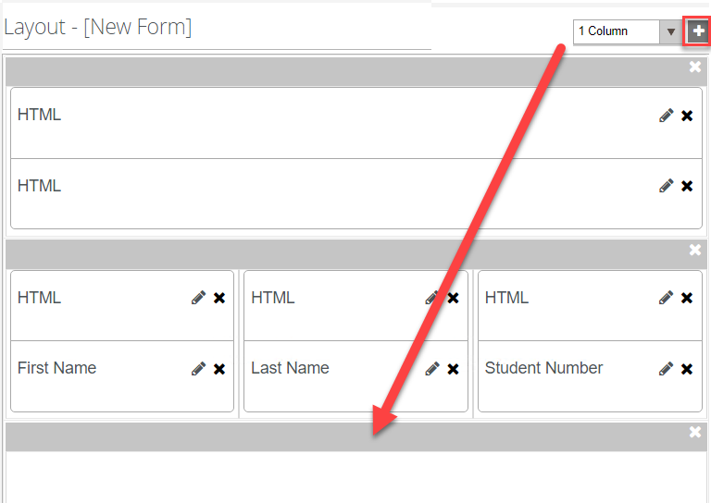

- From the Components tab, drag an HTML component, two Checkbox components and another HTML component into the panel of the Layout pane.
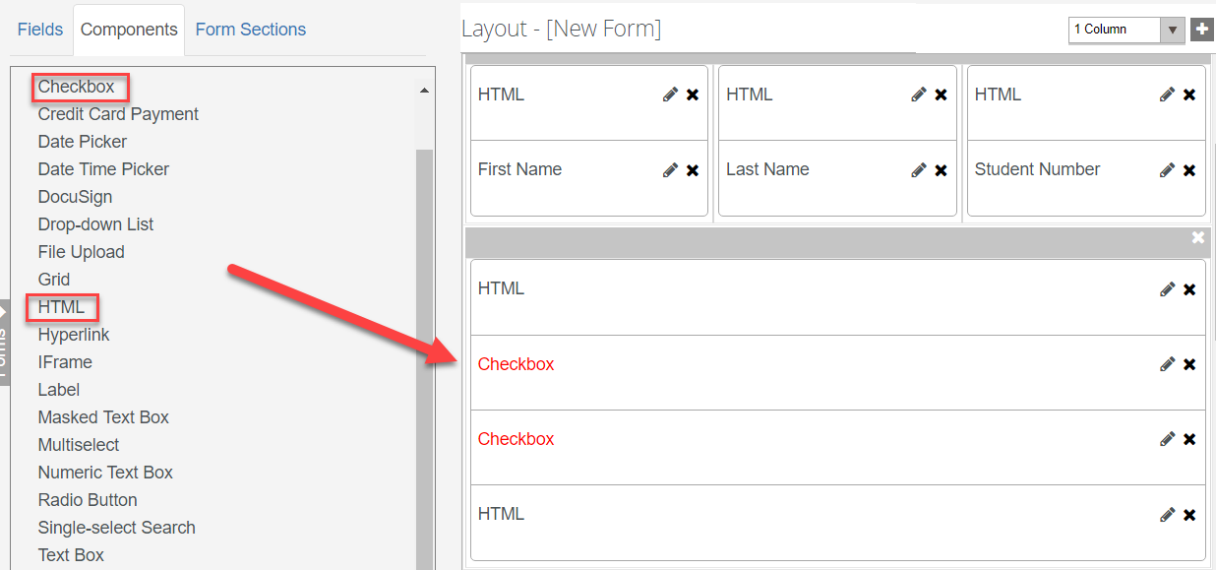

- For the first HTML component, enter the following in the HTML property of the Control Property Settings pane:
<b>Directory Information to Release:</b>

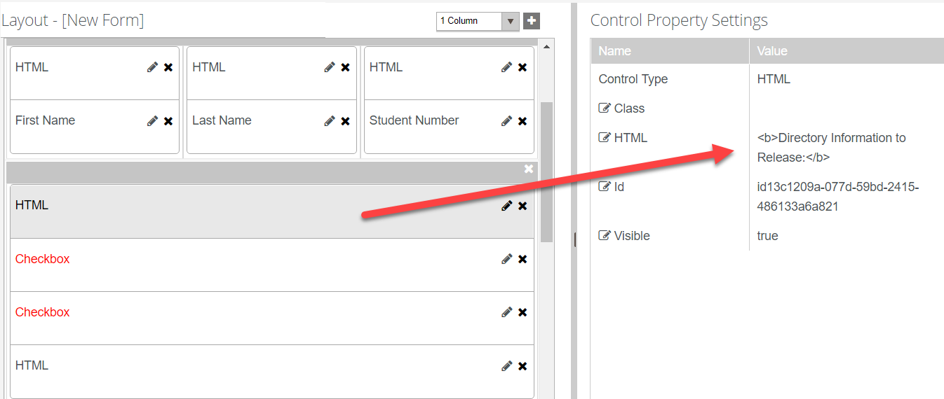

- Update the following properties for the first Checkbox component as shown below:
- Label: I DO NOT authorize Campus University to disclose any personally identifiable information from my student records.
- Model: vm.models.myAckNot

Note: When we create our supporting Workflow, we will create an In/Out Argument of myAckNot. This will allow us to pass data to and from the field on the form.
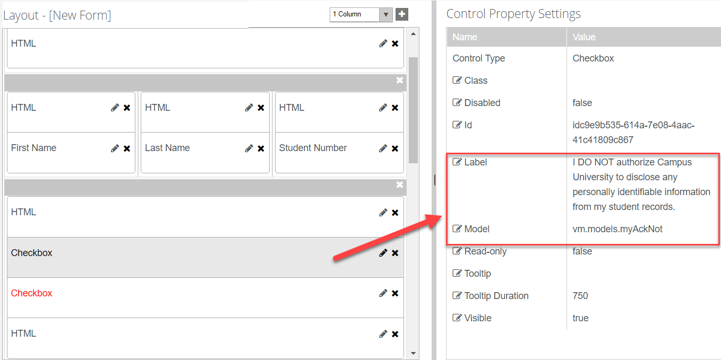

- Update the following properties for the second Checkbox component as shown below:
- Label: I authorize Campus University to disclose all of the following personally identifiable information from my student records as listed below.
- Model: vm.models.myAckTrue

Note: When we create our supporting Workflow, we will create an In/Out Argument of myAckTrue. This will allow us to pass data to and from the field on the form.

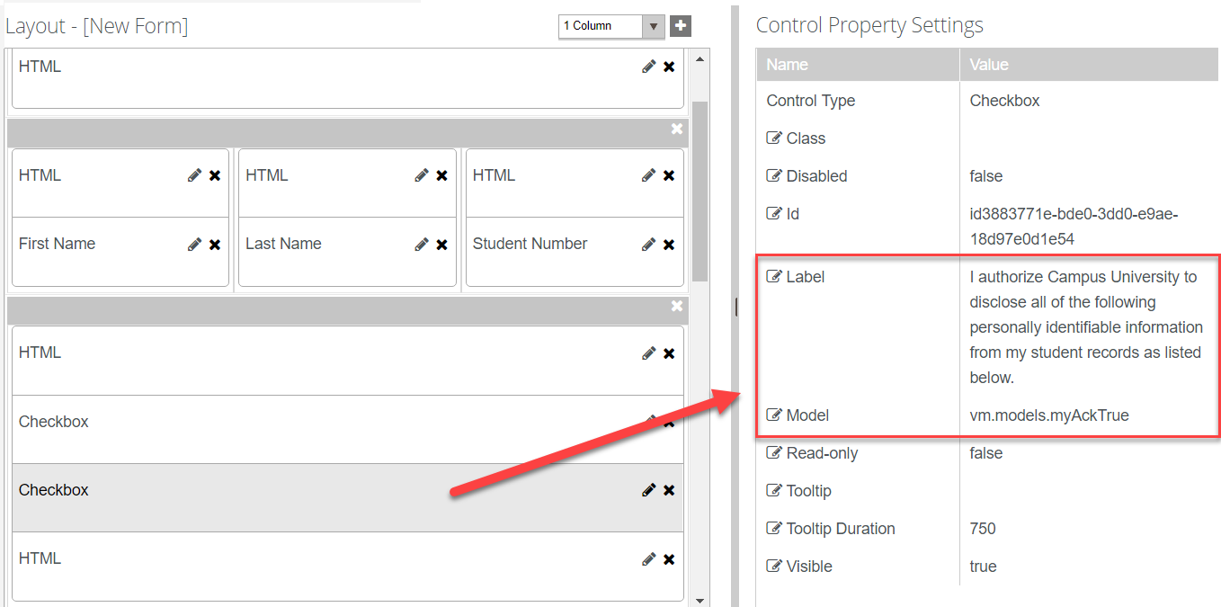

- For the second HTML component, enter the following in the HTML property of the Control Property Settings pane:
<ul style="list-style-type:square;">
<li>Student Name</li>
<li>Address</li>
<li>Telephone Number</li>
<li>E-mail Address</li>
<li>Photograph</li>
<li>Date of Birth</li>
<li>Place of Birth</li>
<li>Campus</li>
<li>Major Field of Study</li>
<li>Dates of Attendance</li>
<li>Grade Level</li>
<li>Enrollment Status</li>
<li>Participation in Activities</li>
<li>Degrees</li>
<li>Honors and Awards</li>
<li>Recent Institution Attended</li>
</ul>

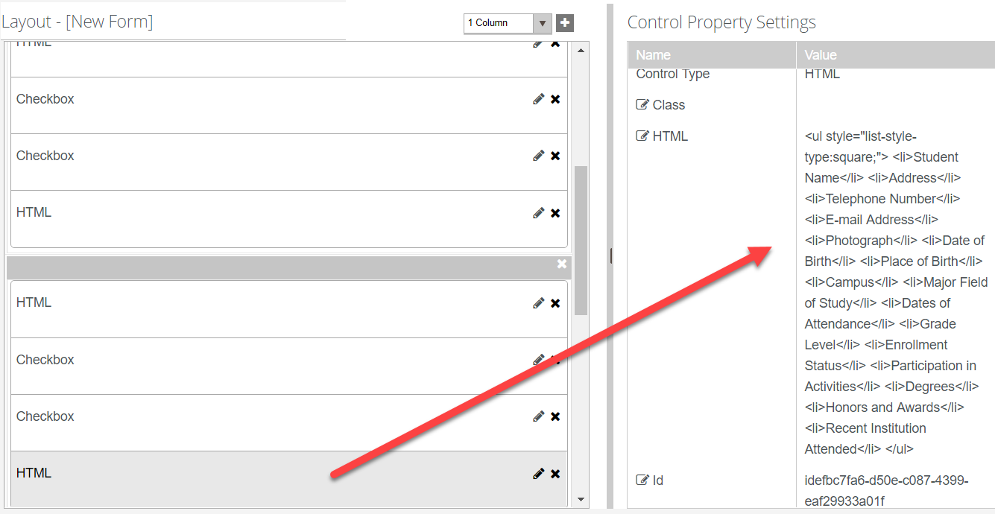

- Click the + and select the column option to add a 3 Column panel to the Layout pane.

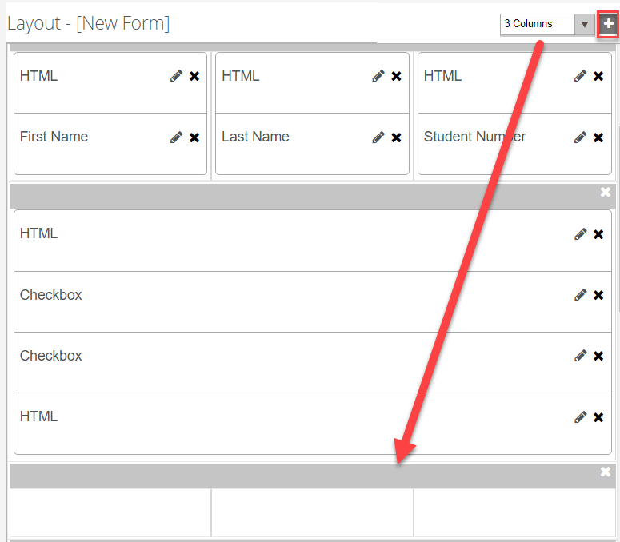

- From the Components tab, drag three HTML components into the panel of the Layout pane.
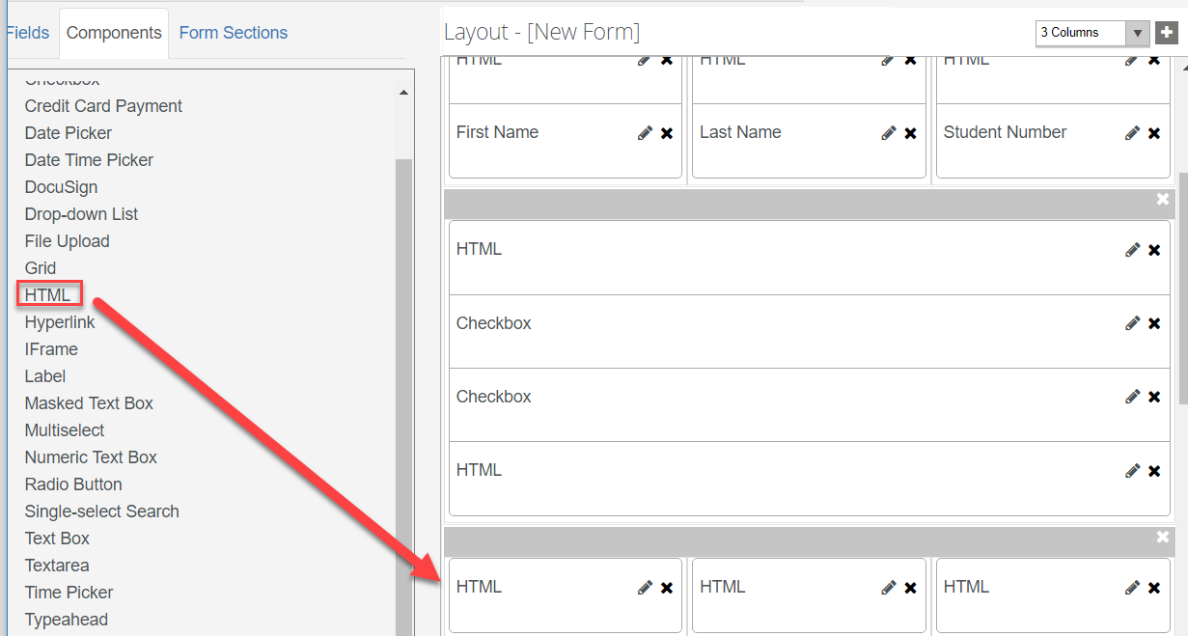

- For the first HTML component, enter the following in the HTML property of the Control Property Settings pane:
<b>Education Information to Release:</b><br><br><b><i>I authorize Campus University to release the following types of Education Information.</i></b>
Note: The second and third HTML components are used as a place holder so we will not enter anything in the Control Property Settings pane for these components.
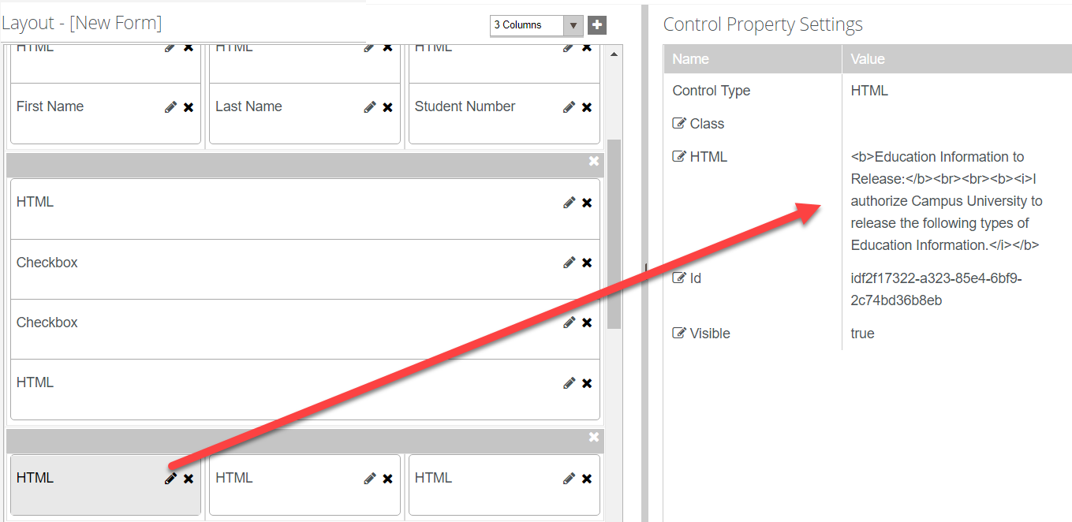

- From the Components tab, drag multiple Checkbox and HTML components into the panel of the Layout pane as shown below.
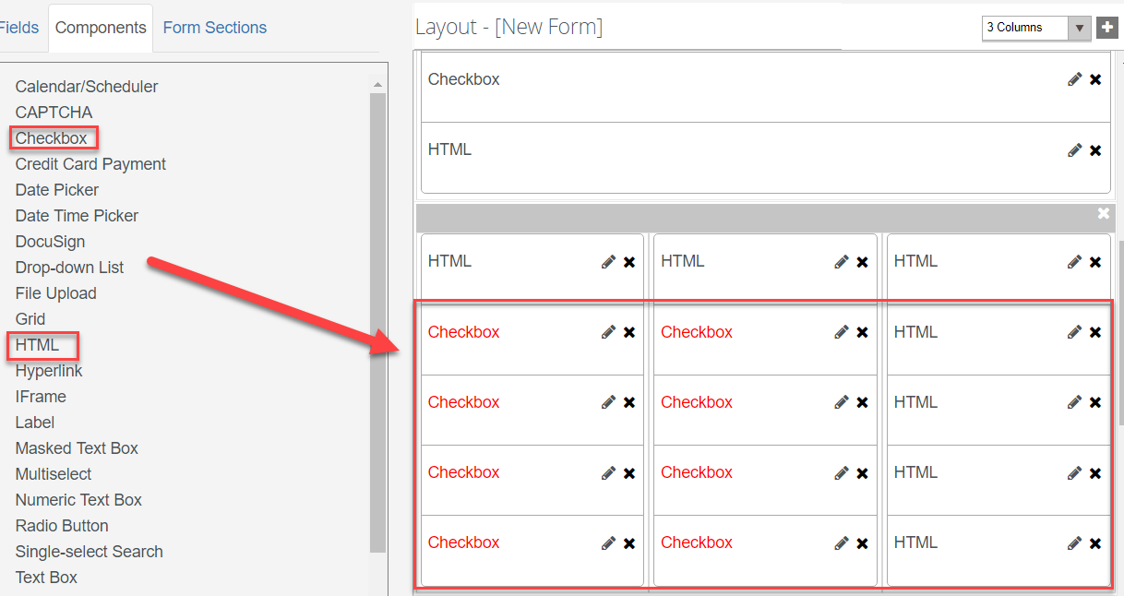
- Complete the properties for each Checkbox component as shown below:
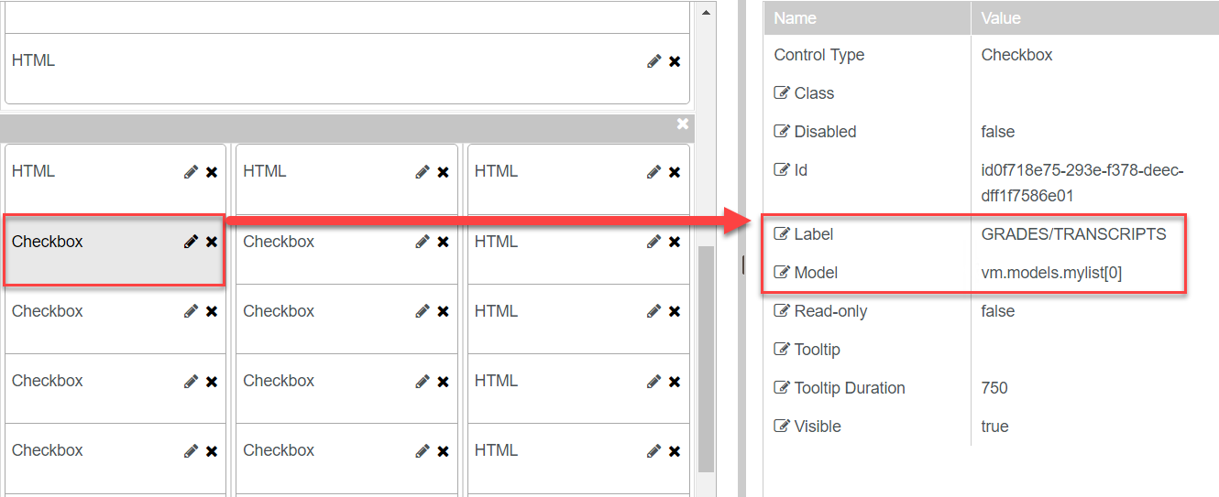

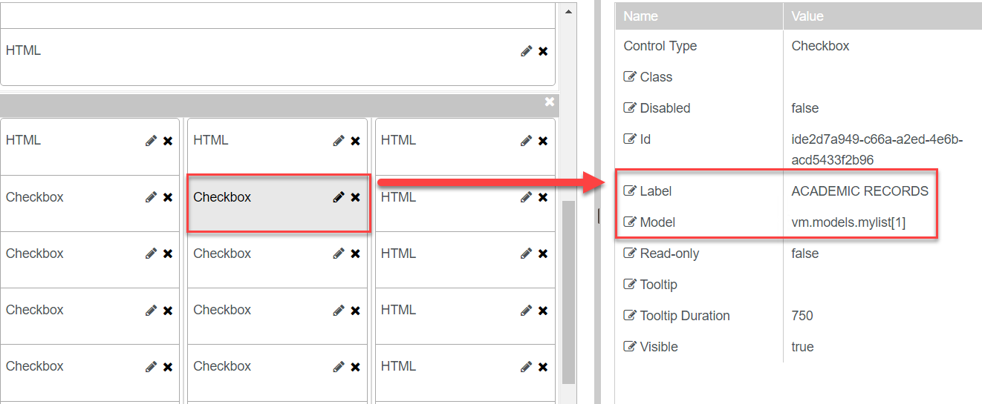

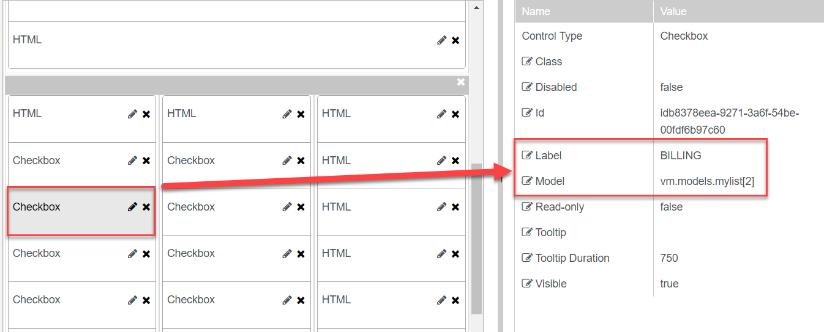
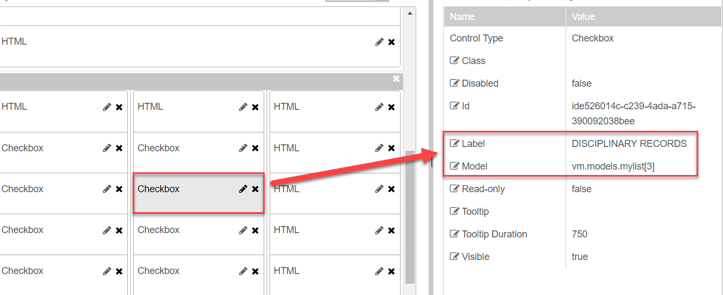
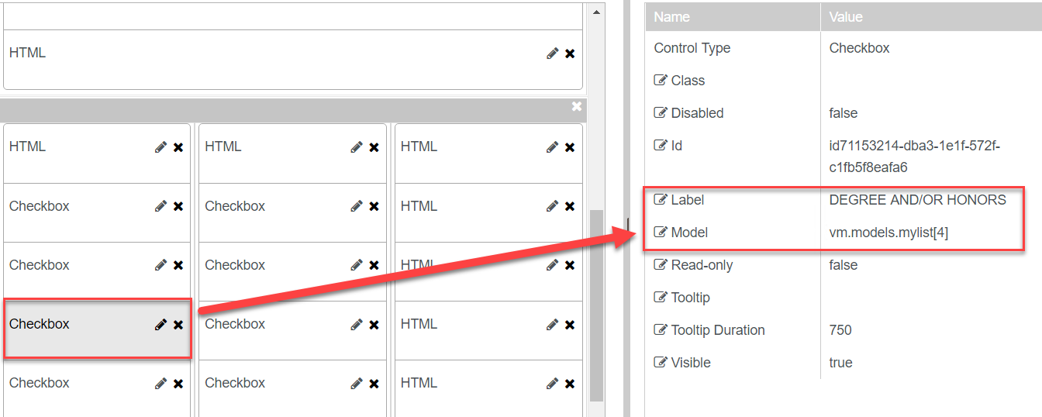

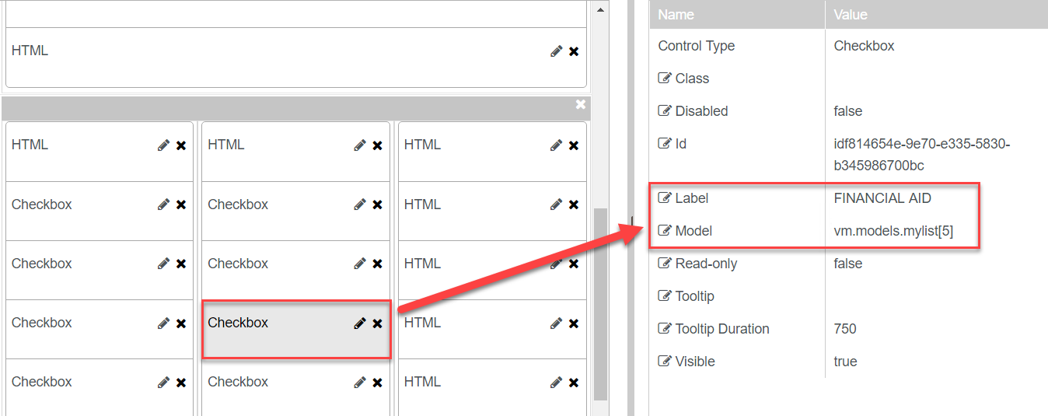
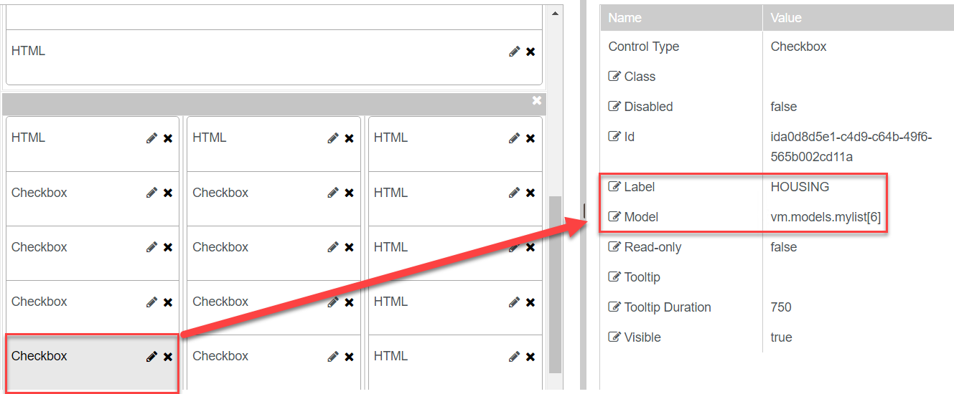
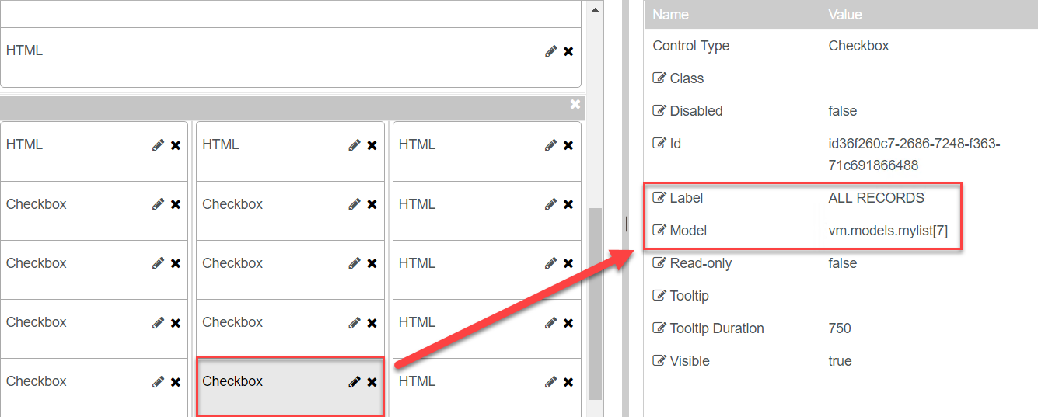

- The HTML components are used as placeholders so we do not need to update any properties for these components.

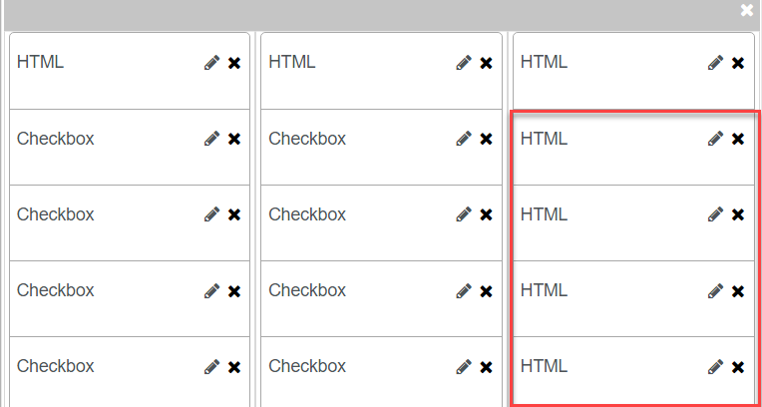

- From the Components tab, drag three HTML components into the panel of the Layout pane.
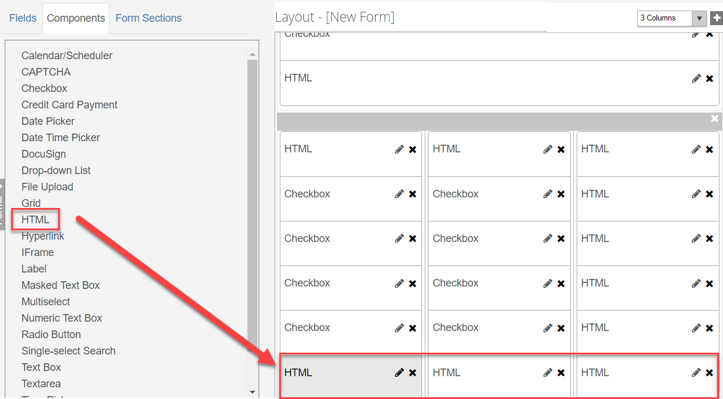
- For the first HTML component, enter the following in the HTML property of the Control Property Settings pane:
<b>Person Authorized:</b><br><br><b><i>This information may be released to the person listed below.</i></b>
Note: The second and third HTML components are used as a place holder so we will not enter anything in the Control Property Settings pane for these components.
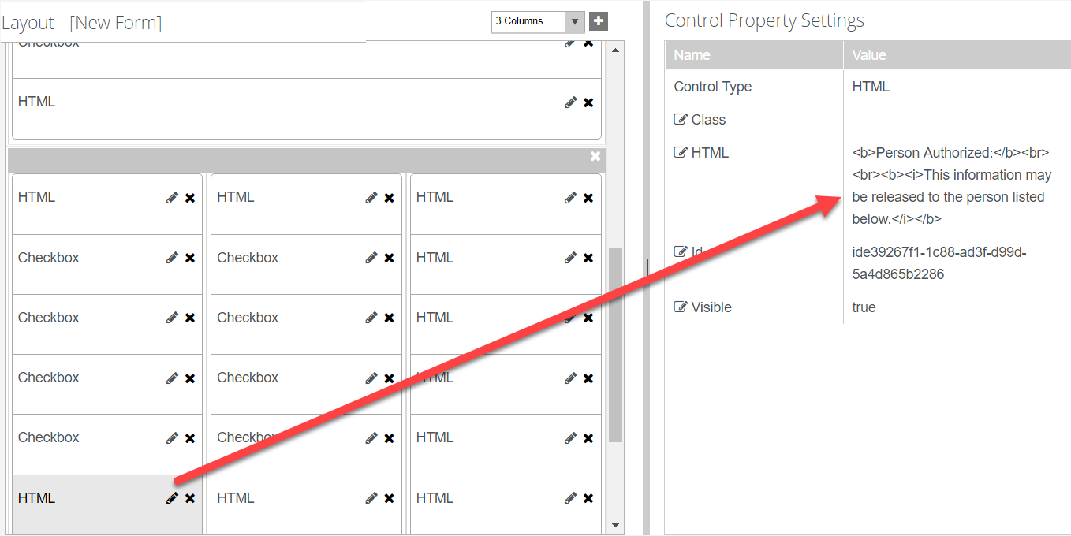

- Select to Show All Fields on the Fields tab. This will load all entities from the data model.
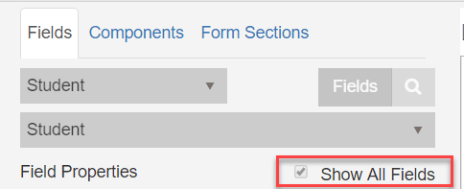

- Once the entities load, select Student Relationship Address from the drop-down.
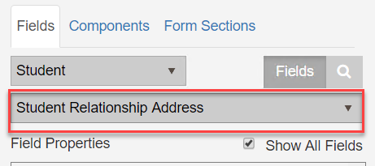

- Drag the following fields into the panel of the Layout pane.
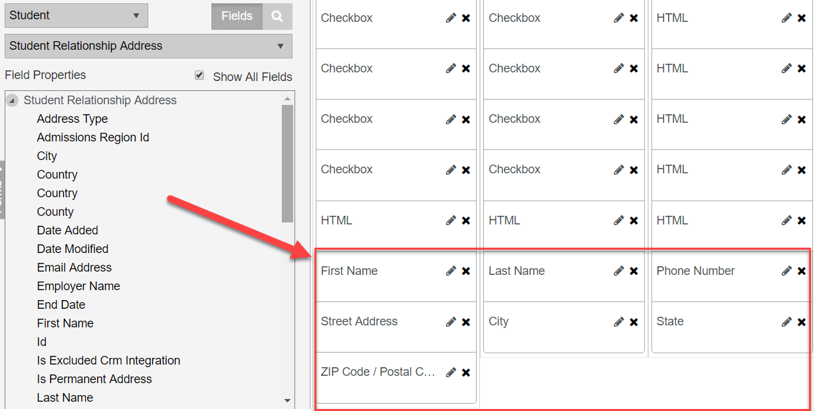

- Make sure the Required property in the Control Property Settings pane is set to true for the all of the fields.


- Drag a Masked Text Box from the components tab above the Phone Number field. Update the properties for the Masked Text Box in the Control Property Settings pane as shown below.
- Format: (###)###-####
- Label: Phone Number
- Model: vm.models.studentRelationshipAddressEntity.PhoneNumber
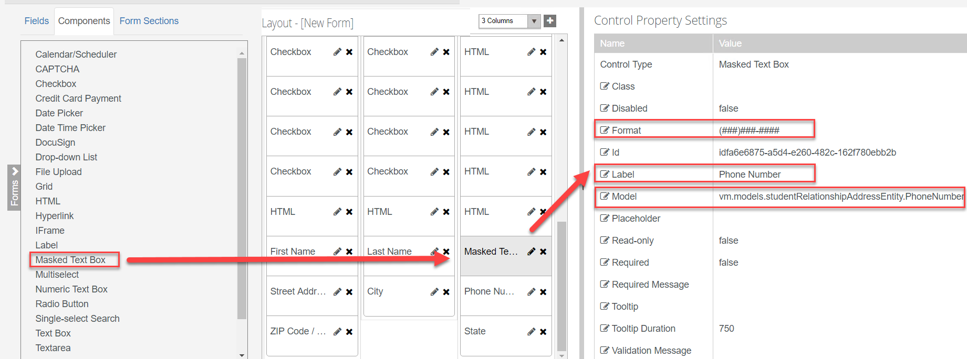

- Delete the Phone Number field from the form.

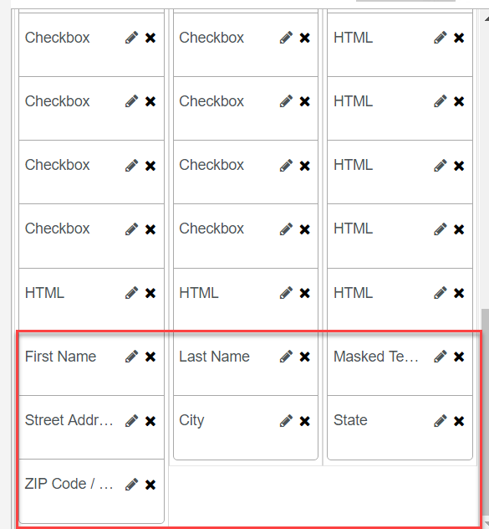

- Save and name your Form with your initials at the end as shown below.
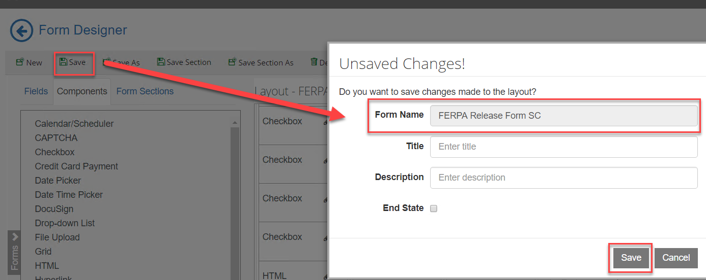

- On the top left bar, click on the arrow to navigate out of Form Designer.
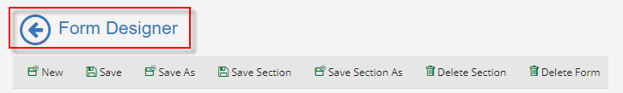

- Select Sequence Designer.
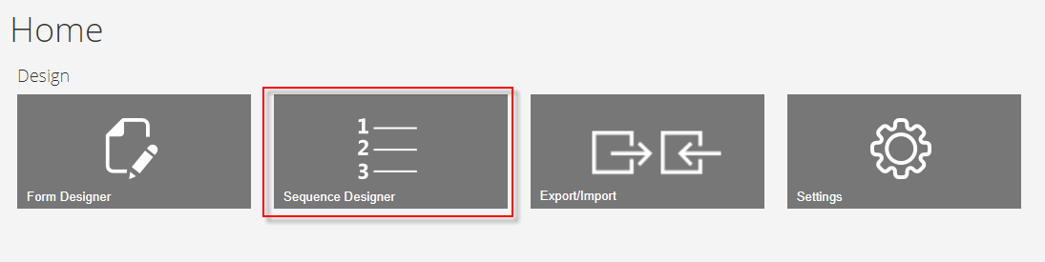
- Select New and a new panel will be created for you to drag your forms into for creating your sequence.
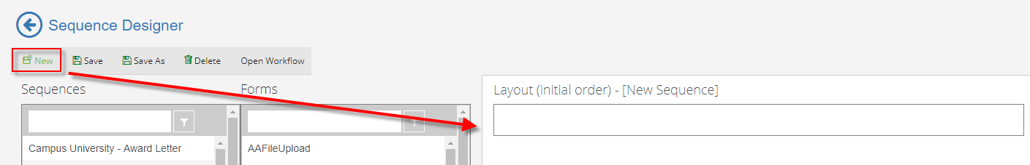

- From the Forms column drag your form in the New Sequence panel in the Layout pane as shown below.
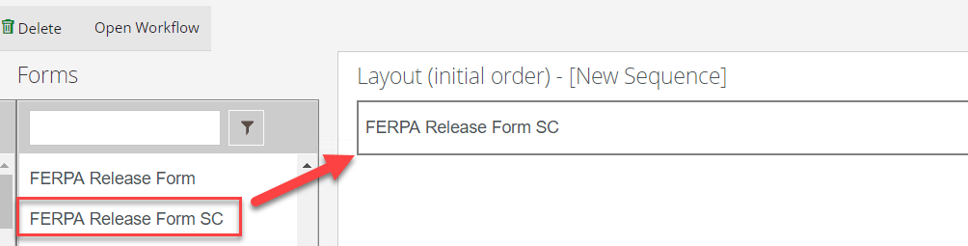

- In the Properties pane, update the properties as shown below and select Save.
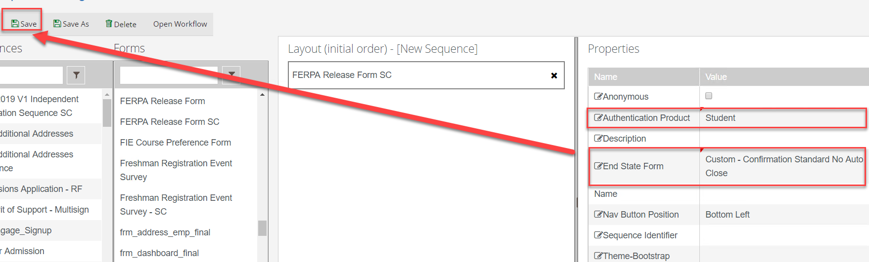
- Save the Sequence with Your initials at the end as shown below.
NOTE: DO NOT PUT EXTRA SPACES OR DASHES IN THE SEQUENCE NAME.

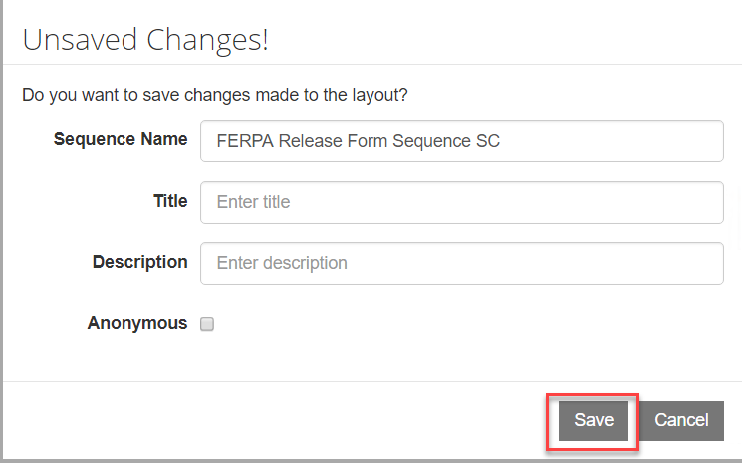

- Once saved, select the Sequence in the Sequence pane and select Open Workflow.
Note: This will open Workflow Composer and create the State Machine Workflow shell for us to start creating our supporting workflow for the form. You can also open up the Workflow directly from Workflow Composer.
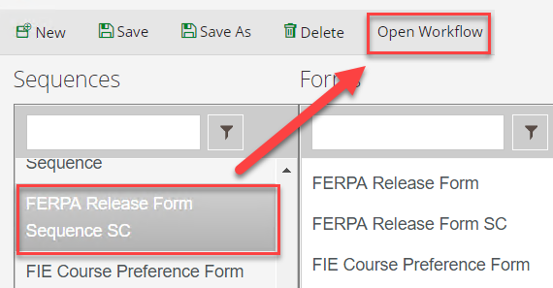

- Rename the StateMachine Flow to StateMachine-FERPA Release of Information. You can do this by double-clicking on the title at the top.
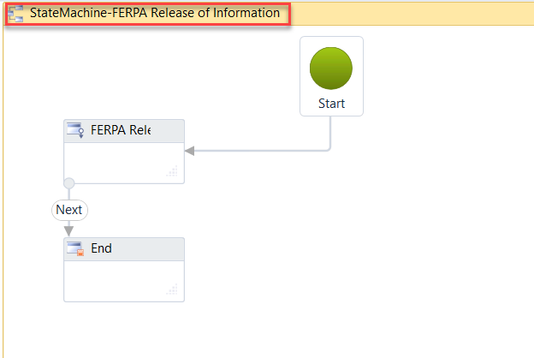

- Select the second sequence in the state machine flow to give it the focus and hit the right arrow on your keyboard to move the sequence to the right. This helps to organize our state machine flow to better navigate.
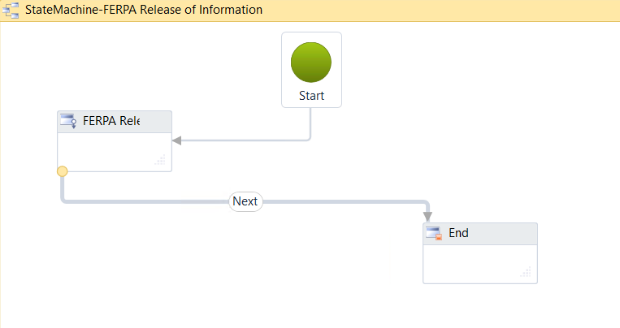

- Create the following Arguments as shown below. These are the model values that we populated on our form fields for our components.
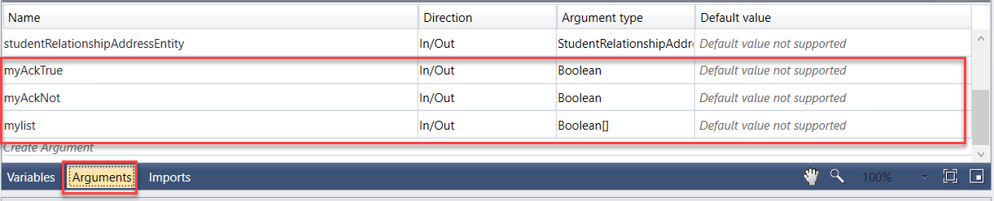

Note: The name has to match the exact model name used for the field on the form. For the mylist argument, for Argument type you will need to select the Array of [T] then select Boolean.

- Double-click the first sequence in the state machine flow. This will allow you to go to the first transition in your form. We can specify in this section what we want to occur when the student enters the form.

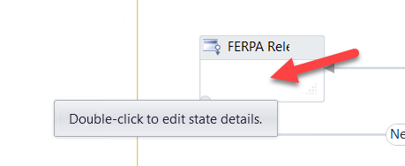

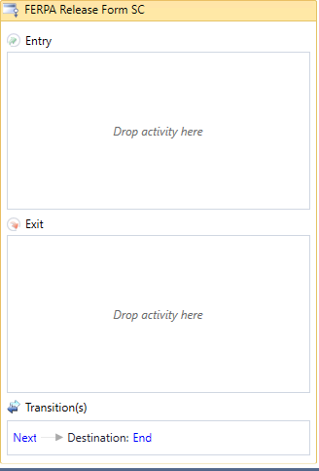

- We want to organize our Workflow by adding containers to specify what we are doing in each section. This will allow us to better understand and visualize the logic occurring within the Workflow.
- Drag a Sequence activity onto the designer in the Entry section of the activity. Rename the sequence to Find Student.
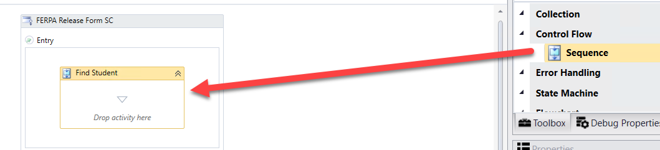

- The first thing that we want to do is find the student that is completing the form in order to initialize the form and display values back to our FERPA Release Form as needed. We will then continue finding and assigning other values that we will need for the form as the student moves through the sequence.

- Drag the LookupUser activity onto the designer into the Find Student Sequence. We use this activity to find the student completing the form.
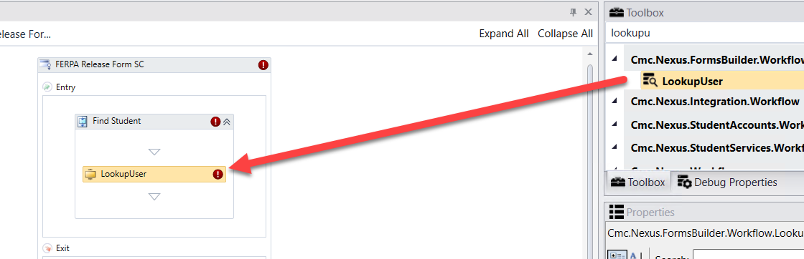

- Create a variable:
- Name: studentid
- Variable type: Int32
- Scope: StateMachine-FERPA Release of Information
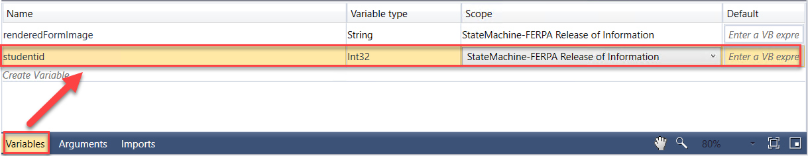
- Complete the properties for the LookupUser activity as shown below:

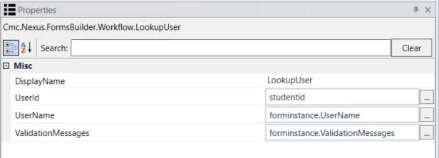

- We then want to get the data from the studentEntity so we can display it back to our form. We use the GetEntity activity since we already have the student in the CampusNexus Student database.
- Drag the GetEntity activity onto the designer below the LookupUser activity.
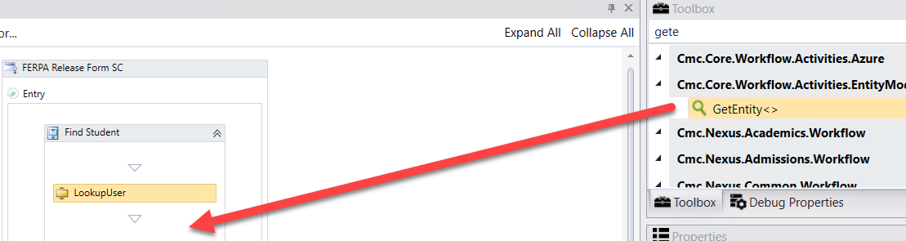
- When the box pops up, Browse for Types.
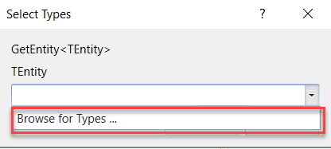
- Navigate to: Cmc.Nexus.Common.Contracts>Cmc.Nexus.Common.Entities>StudentEntity and click OK.
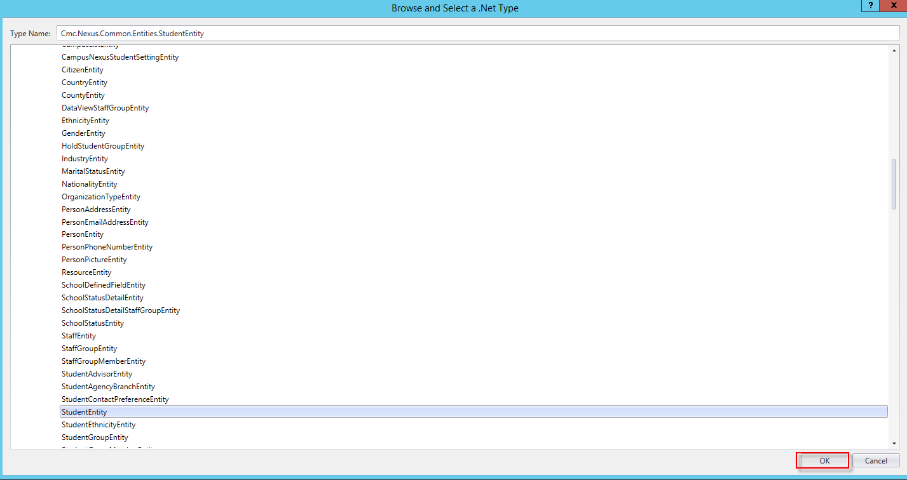
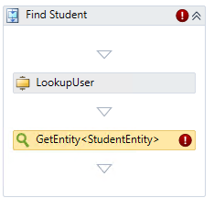
- Specify the properties in the Properties pane for the GetEntity activity.
Note: The EntityId is your variable of studentid and the Result is the studentEntity.
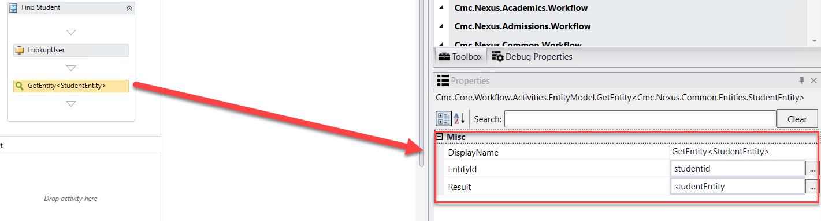

- Drag two Assign activities onto the Designer in the Find Student Sequence activity below the GetEntity activity. Update the properties as follows:
- Display Name: Assign Data Block Indicator; studentEntity.DataBlockIndicator=True
- Display Name: Assign list to array;
mylist=New Boolean() {false, false, false, false, false, false, false, false}

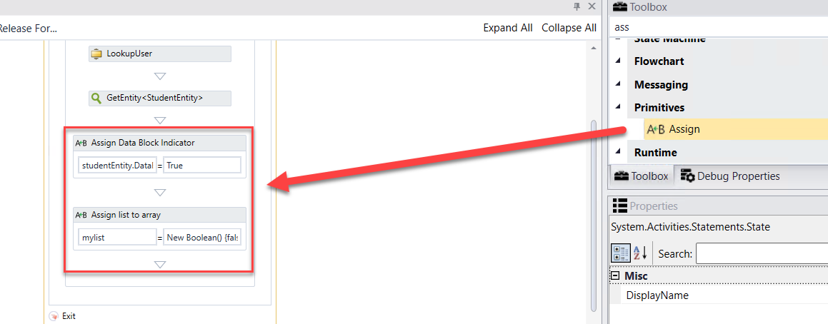
- In our FERPA Release Form Sequence, we will be adding an address for the student in the Addresses Folder in CampusNexus Student for FERPA. We need to create the entity so once we collect the data from the student on the form we can save the values back to the database.
- Drag a CreateEntity activity onto the designer below the Assign list to array Assign activity
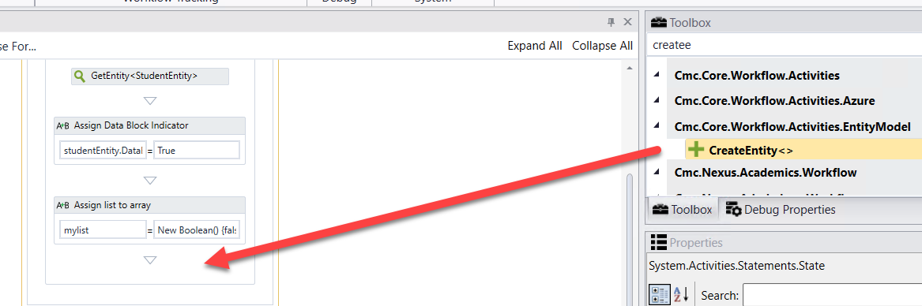

- When the box pops up, Browse for Types.
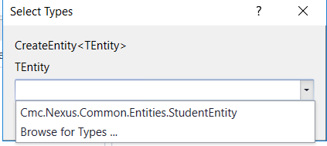

- Navigate to: Cmc.Nexus.Common.Contracts>Cmc.Nexus.Common.Entities>StudentRelationshipAddressEntity and click OK.

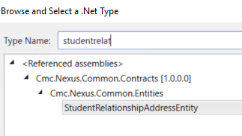
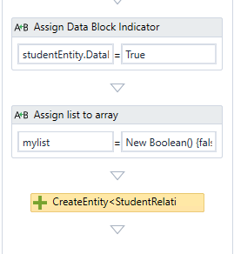

- Specify the properties in the Properties pane for the CreateEntity activity as shown below:
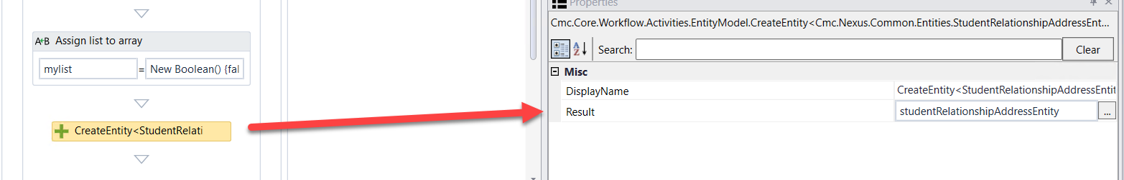

- Click Next at the bottom of the form to enter the next transition of your FERPA Release of Information Form Sequence.

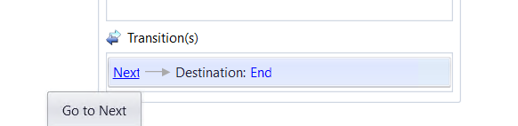

- Rename the WaitForFormBookmark activity and the Next button transition text to Submit. Update the Condition as shown below.
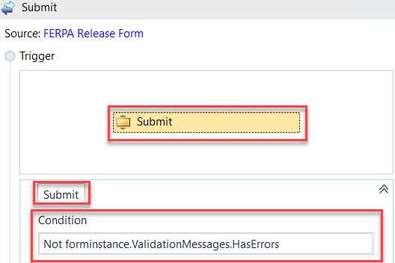

- We want to organize our Workflow by adding containers to specify what we are doing in each section. This will allow us to better understand and visualize the logic occurring within the Workflow.
- Drag three Sequence activities onto the designer below the Submit WaitForFormBookmark activity. This will also create a Sequence activity automatically around all of the activities.
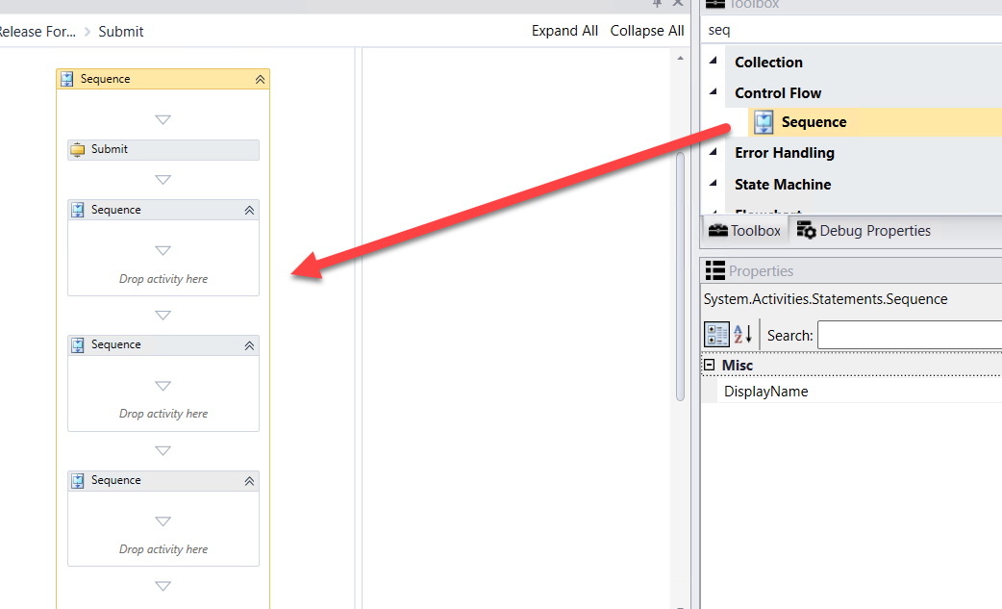

- Rename each Sequence activity as shown below.
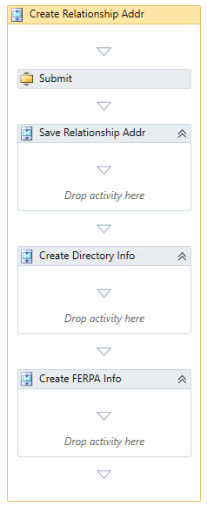

- Drag two Assign activities onto the Designer in the Save Relationship Addr Sequence activity. Update the properties as follows:
- Display Name: Assign StudentID; studentRelationshipAddressEntity.StudentId=studentEntity.Id
- Display Name: Assign Address Type;
studentRelationshipAddressEntity.AddressTypeId=27

Note: The AddressTypeId of 27 is the Id from the database for the FERPA address type.
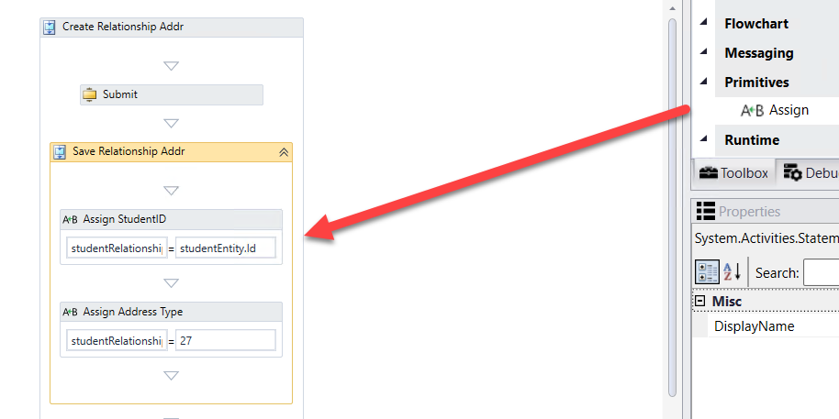

- We now want to save the StudentRelationshipAddressEntity information. To save the data, drag a SaveEntity below the Assign Address Type Assign activity.
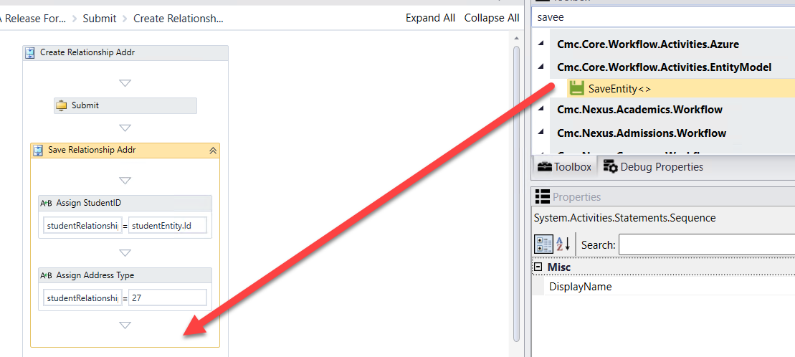

- When the box pops up, Browse for Types.

- Navigate to: Cmc.Nexus.Common.Contracts>Cmc.Nexus.Common.Entities>StudentRelationshipAddresEntity and click OK.
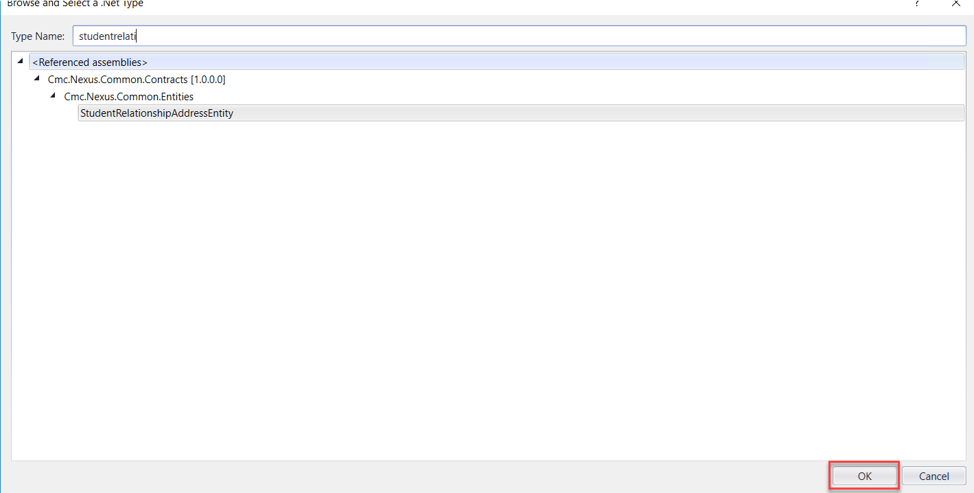

- Specify the properties in the Properties pane for the SaveEntity activity.
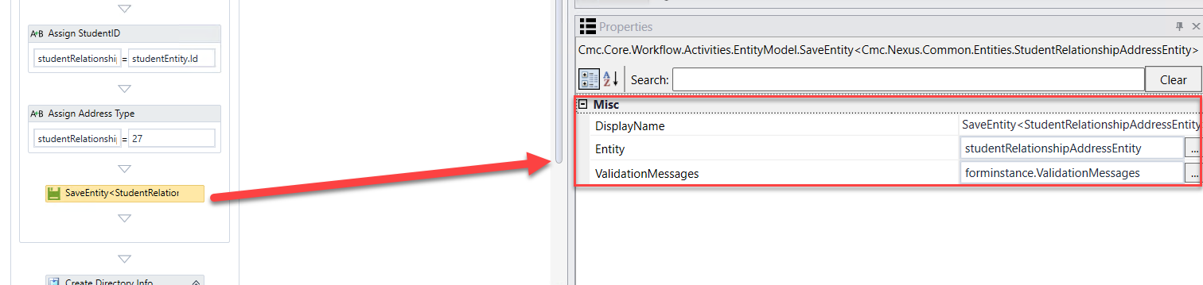

- We now want to save the StudentEntity information. To save the data, drag a SaveEntity below the SaveEntity StudentRelationshipAddressEntity activity.
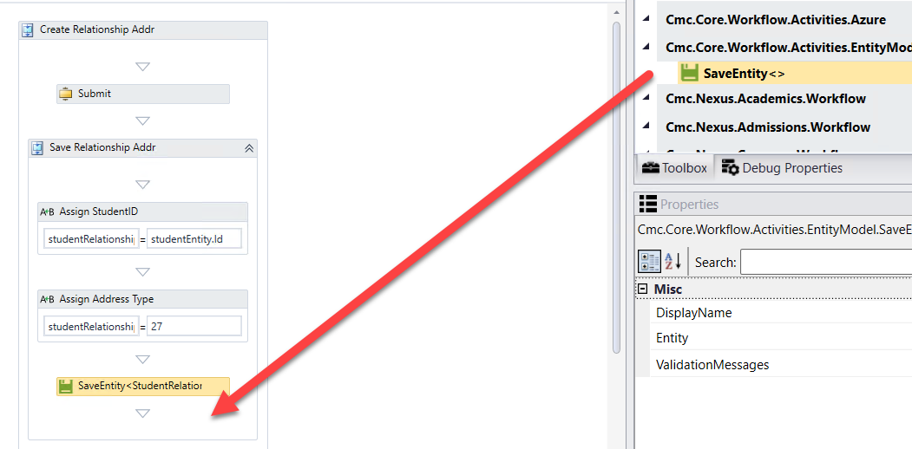

- When the box pops up, Browse for Types.

- Navigate to: Cmc.Nexus.Common.Contracts>Cmc.Nexus.Common.Entities>StudentEntity and click OK.
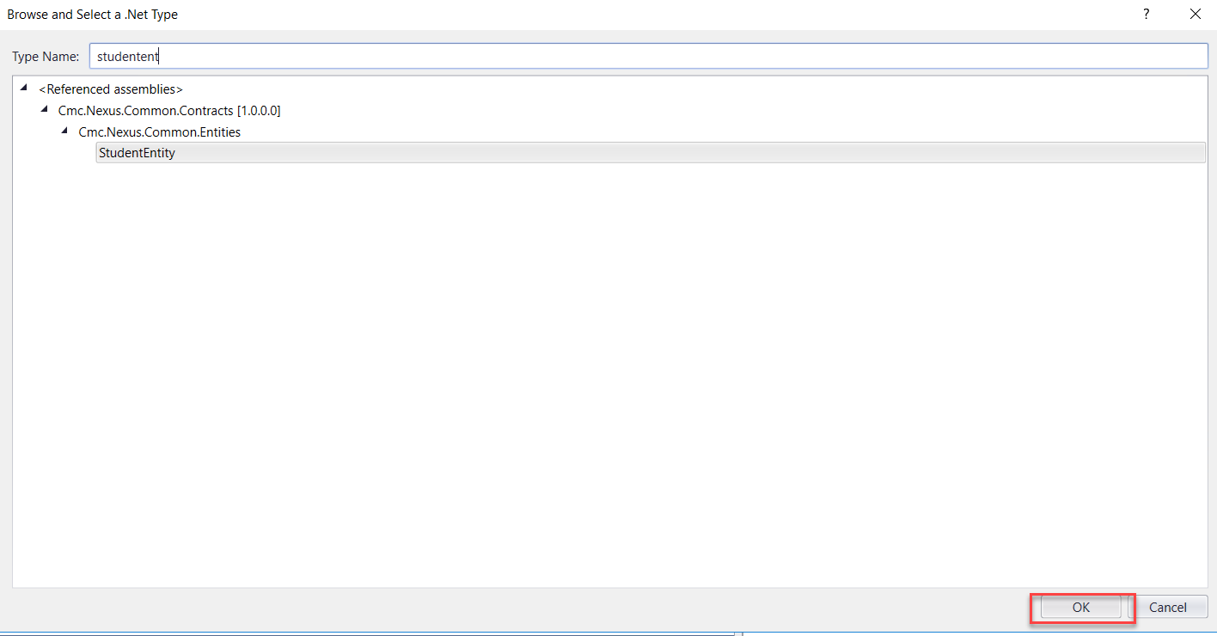

- Specify the properties in the Properties pane for the SaveEntity activity.

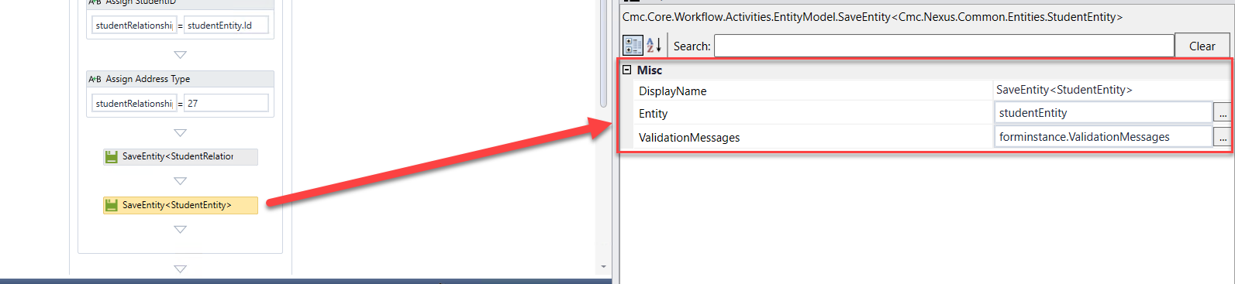

- Drag an If activity into the Create Directory Info Sequence activity.
- Rename the activity to: If value to share is true
- Condition: myAckTrue=True
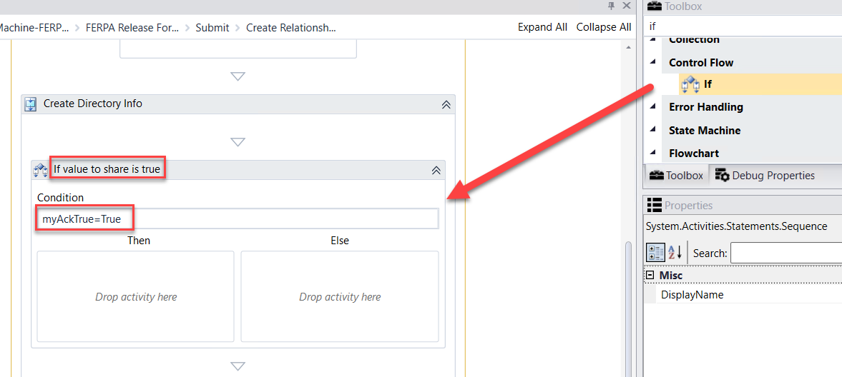

- Drag a Sequence activity into the Then portion of the If activity. Rename the activity to: Mark field to share
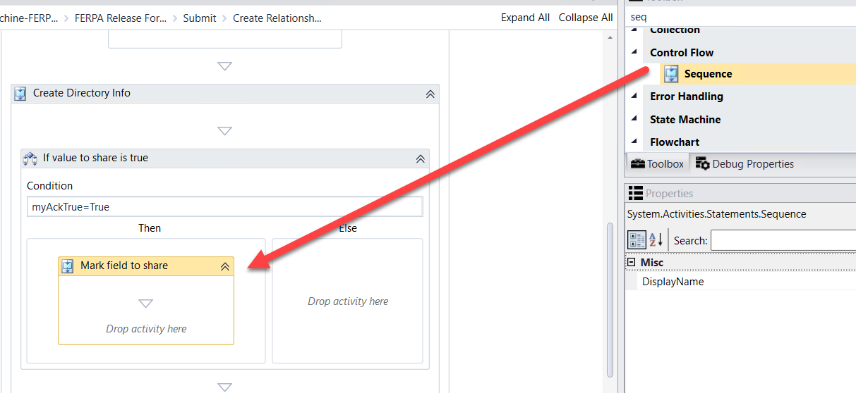

- Create the following variables:
- Name: StudentRelationship; Type: Cmc.Nexus.Crm.Contracts>Cmc.Nexus.Crm.Entities>FerpaStudentRelationshipEntity; Scope: StateMachine-FERPA Release for Information
- Name: AcademicRelease; Type: Cmc.Nexus.Crm.Contracts>Cmc.Nexus.Crm.Entities>FerpaStudentReleaseAcademicFieldEntity; Scope: StateMachine-FERPA Release for Information
- Name: DirectoryShare; Type: Cmc.Nexus.Crm.Contracts>Cmc.Nexus.Crm.Entities>FerpaStudentDirectoryFieldEntity; Scope: StateMachine-FERPA Release for Information
- Name: count; Type: Int32; Scope: StateMachine-FERPA Release for Information

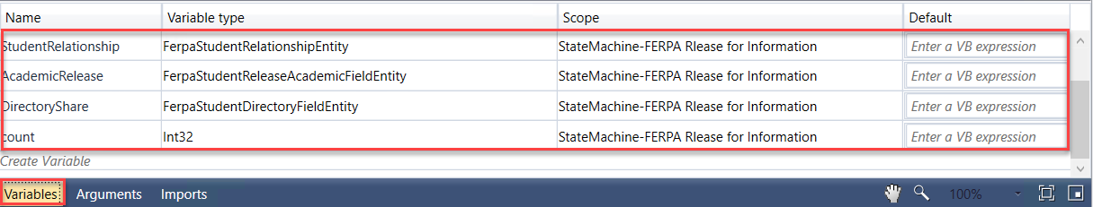

- Drag an Assign activity into the Mark field to share Sequence activity. Complete the activity as follows:
- Rename the activity: Assign Initial Count
- count=1
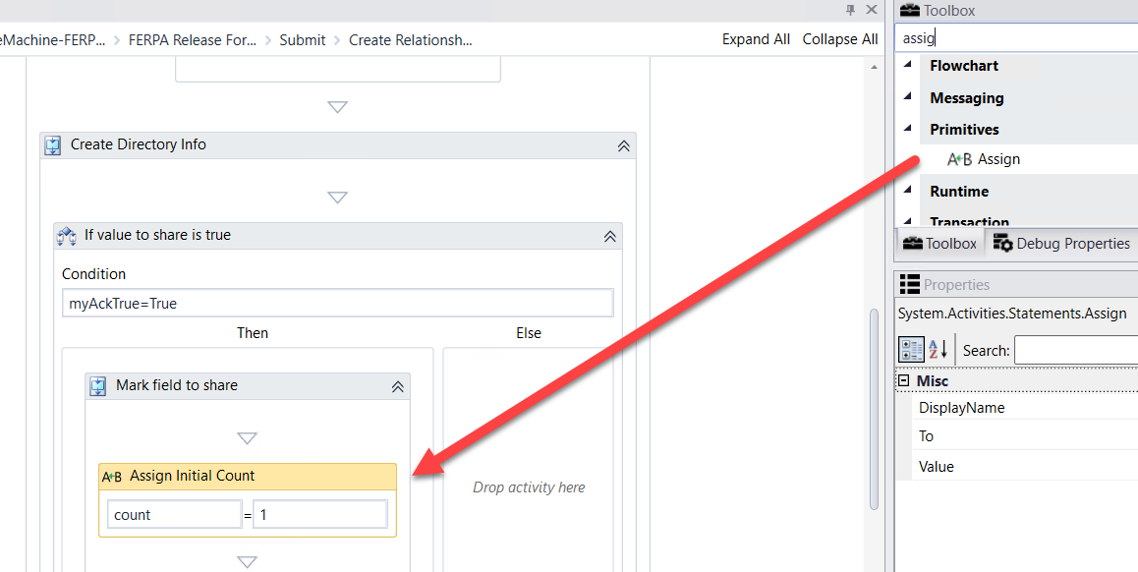

- Drag a DoWhile activity below the Assign Initial Count Assign activity. For the Condition enter the following: count<17
Note: There are 16 directory Id's in the table. We are going to loop through and add each one as selected/unselected for the student relationship table.
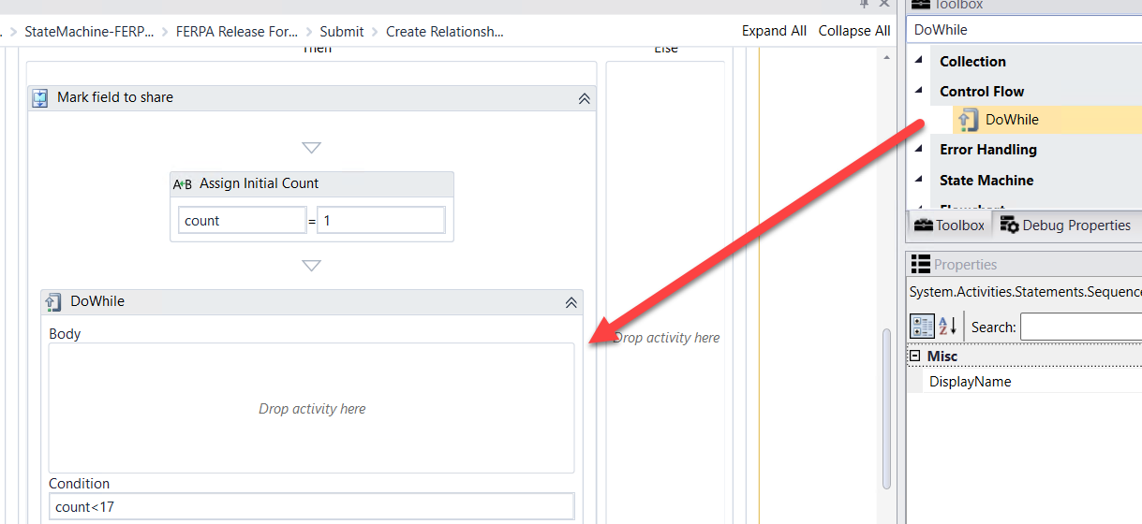

- Drag a Sequence activity into the Body of the DoWhile activity. Rename the activity to:
Create Directory Info

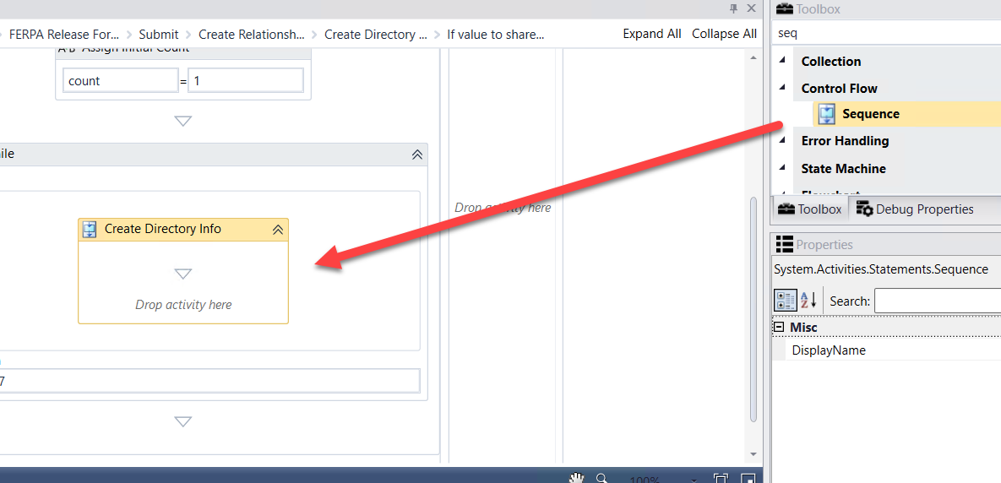

- Drag a CreateEntity activity in the Create Directory Info Sequence activity.
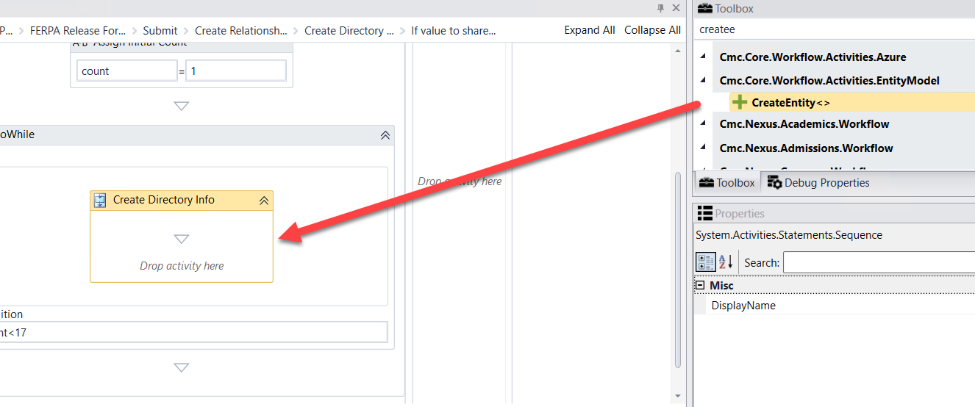

- Browse for Type: Cmc.Nexus.Crm.Contracts>Cmc.Nexus.Crm.Entities>FerpaStudentDirectoryFieldEntity and Click OK
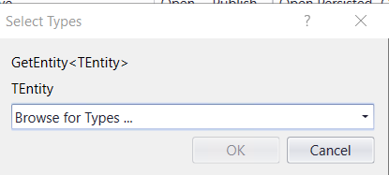
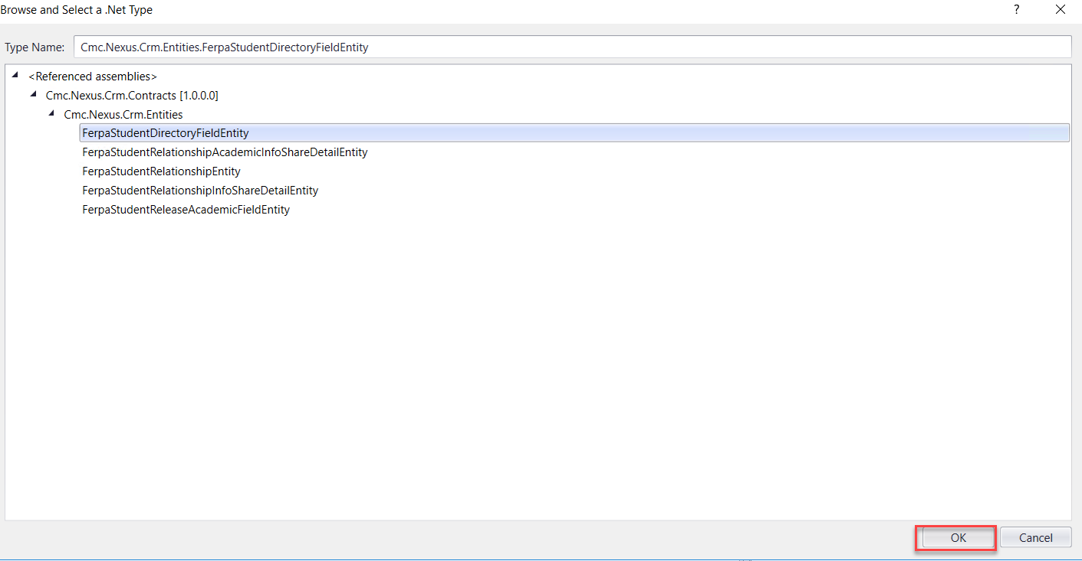

- Complete the properties as shown below.

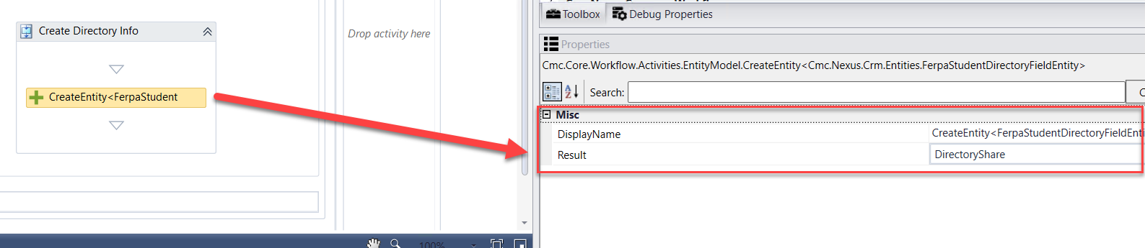

- Drag two Assign activities onto the Designer below the CreateEntity FerpaStudentDirectoryFieldEntity activity. Update the properties as follows:
- Display Name: Map Id; DirectoryShare.StudentId=StudentRelationshipAddressEntity.StudentId
- Display Name: Assign Id;
DirectoryShare.FerpaDirectoryFieldId=count

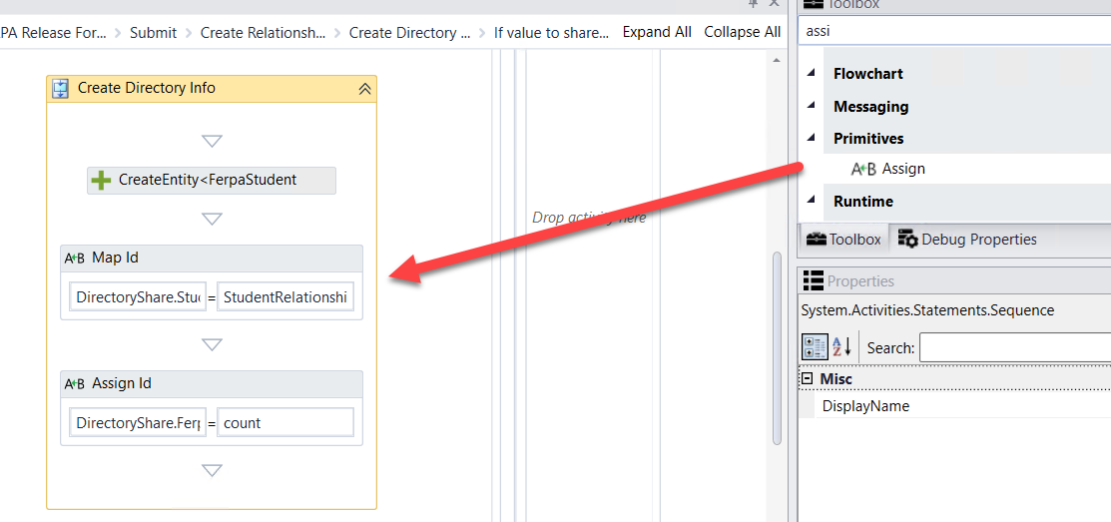

- Drag the SaveEntity activity below the Assign Id Assign activity.

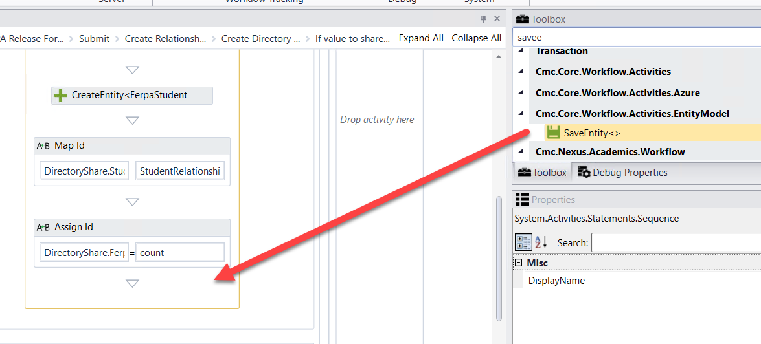
- Browse for Type: Cmc.Nexus.Crm.Contracts>Cmc.Nexus.Crm.Entities>FerpaStudentDirectoryFieldEntity and Click OK


- Complete the properties as shown below.
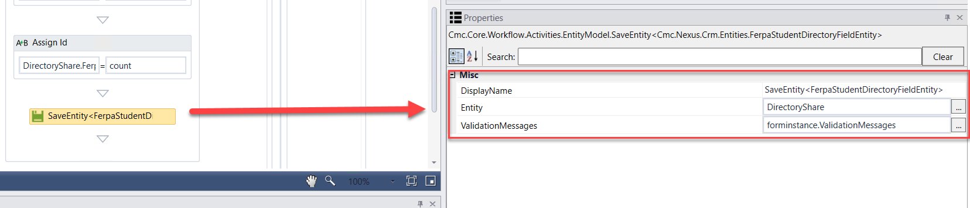

- Drag an Assign activity below the SaveEntity FerpaStudentDirectoryFieldEntity activity. Update the activity as follows:
- Rename: Assign count increment
- count=count+1

Note: Our count starts at 1 and we are going to increment by 1 until we reach 16. This will create all 16 Id's in the student relationship table.
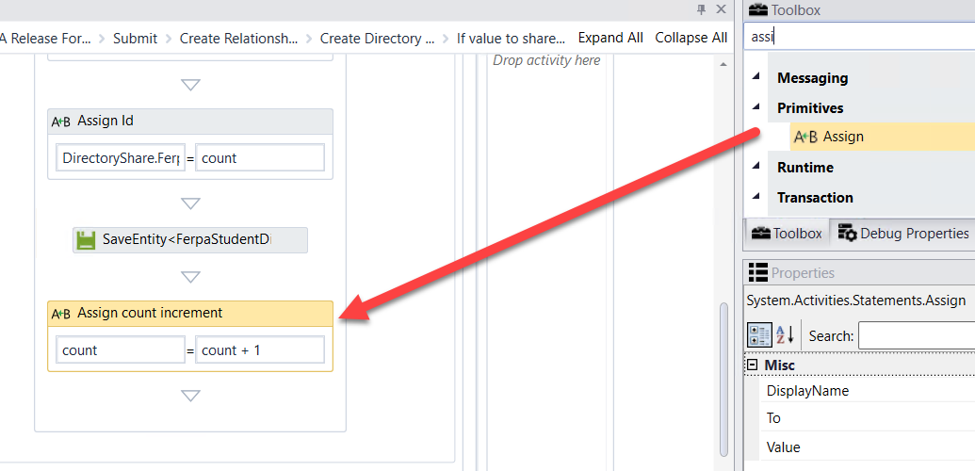

- Drag an If activity into the Create Directory Info Sequence activity.
- Rename the activity to: If value to not share is true
- Condition: myAckNot=True
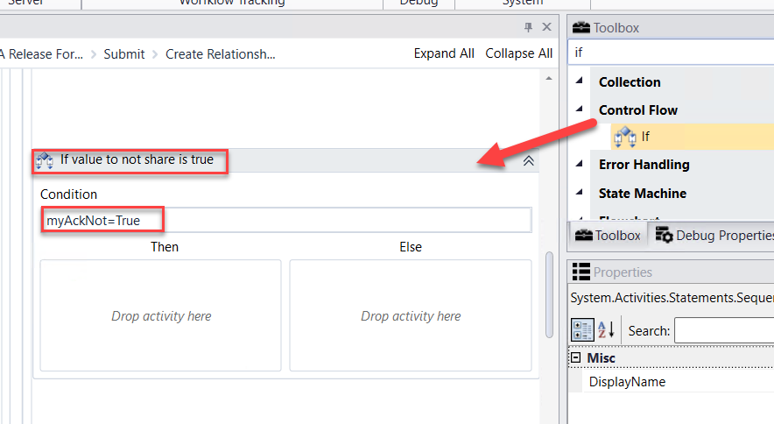

- Drag an ExecuteQuery activity into the Then portion of the If value to not share is true If activity. Update the following for the activity:
- Rename: Delete directory records
- Command: "delete from CmFERPADirStudentRelation where systudentid = " & studentid
Note: If the student selects to NOT release directory information then any records that are in the student relationship table will be removed.
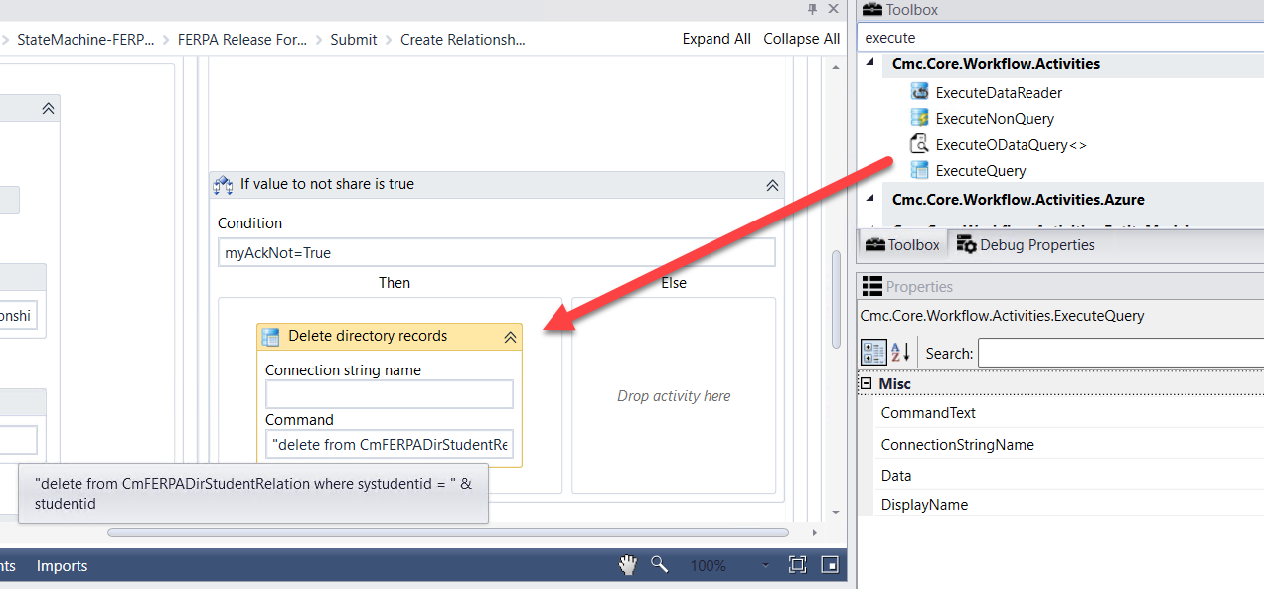

- Drag a CreateEntity activity in the Create FERPA Info Sequence activity.
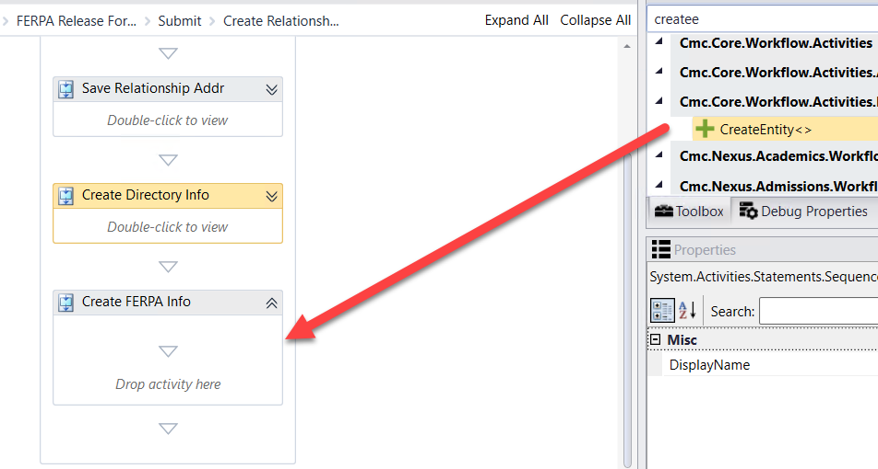

- Browse for Type: Cmc.Nexus.Crm.Contracts>Cmc.Nexus.Crm.Entities>FerpaStudentRelationshipEntity and Click OK

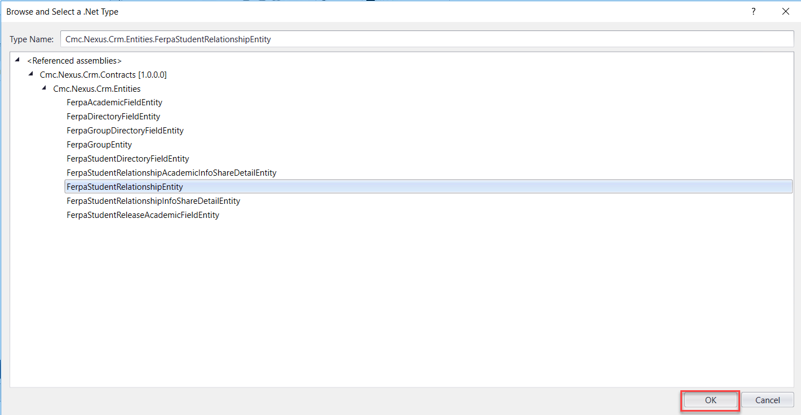

- Complete the properties as shown below.

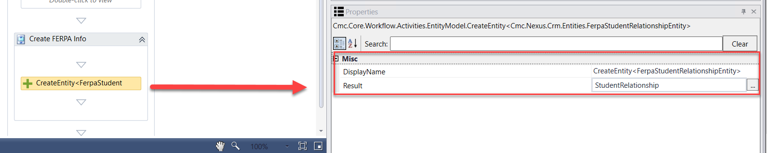

- Drag five Assign activities onto the Designer below the CreateEntity FerpaStudentRelationshipEntity activity. Update the properties as follows:
- Display Name: Map Address Id; StudentRelationship.StudentRelationshipAddressId=studentRelationshipAddressEntity.Id
- Display Name: Assign Description;
StudentRelationship.Description="Form Submission"
- Display Name: Assign Share Info Start Date;
StudentRelationship.ShareInfoStartDate=datetime.Today
- Display Name: Assign Share Info End Date;
StudentRelationship.ShareInfoEndDate=datetime.Today.AddMonths(12)
- Display Name: Assign as Active Record;
StudentRelationship.IsActive=True

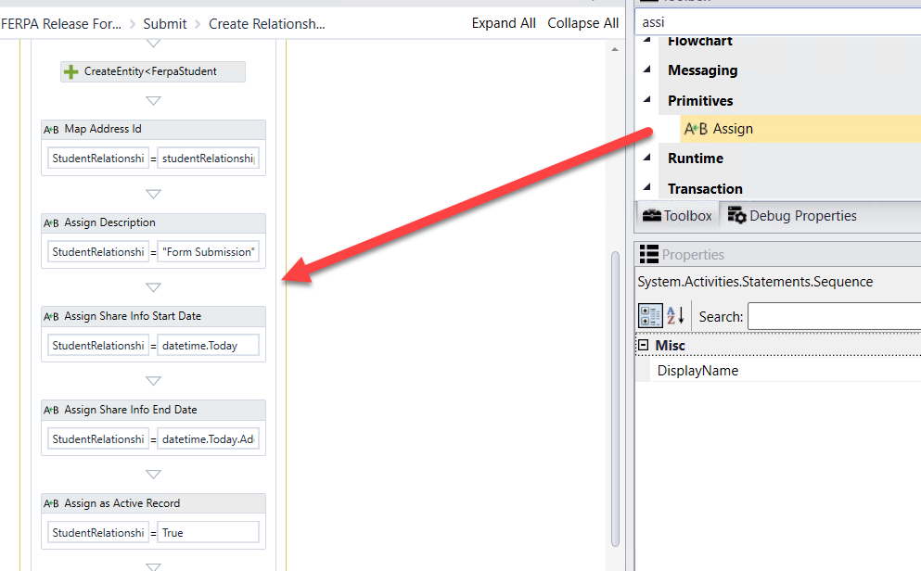

- Drag a Sequence activity below the Assign as Active Record Assign activity. Rename the activity to: Academic Info to Share
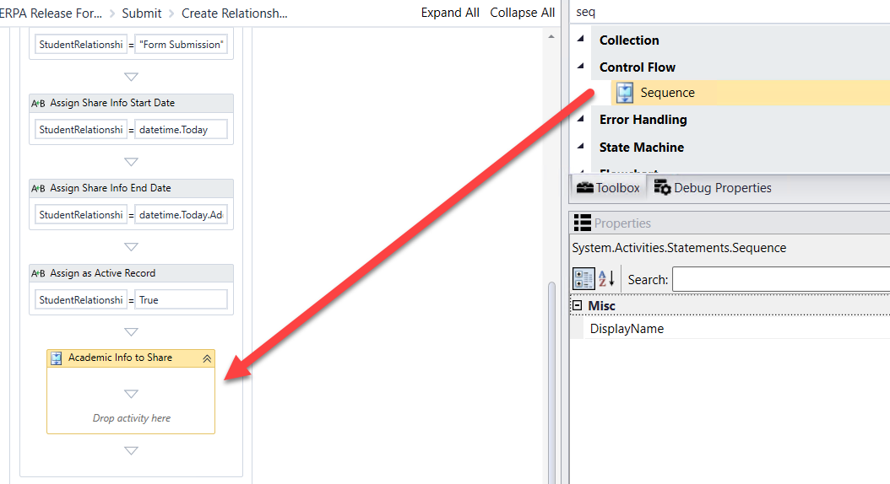

- Drag an Assign activity into the Academic Info to Share Sequence activity. Complete the activity as follows:
- Rename the activity: Assign Initial Count
- count=0
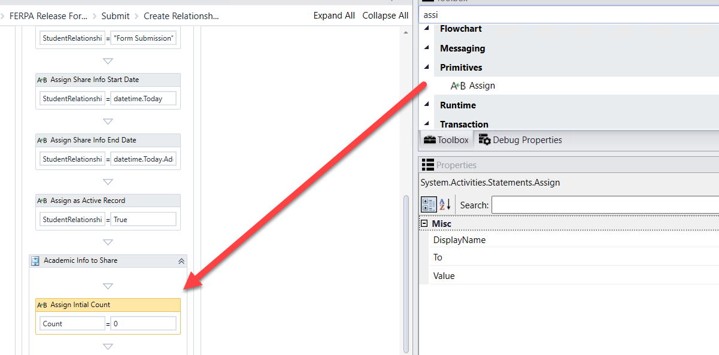

- Drag a DoWhile activity below the Assign Initial Count Assign activity. For the Condition enter the following: count<8
Note: There are 8 directory Id's in the table. We are going to loop through and add each one as selected/unselected based on the selection on the form.
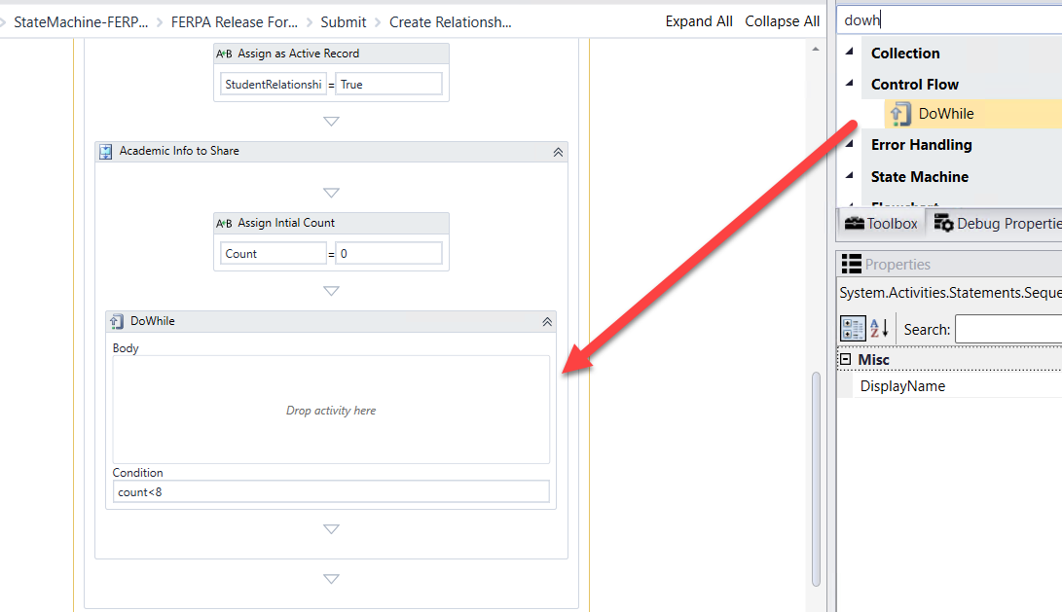

- Drag a Sequence activity into the Body of the DoWhile activity. Rename the activity to:
Save AD Directory Info
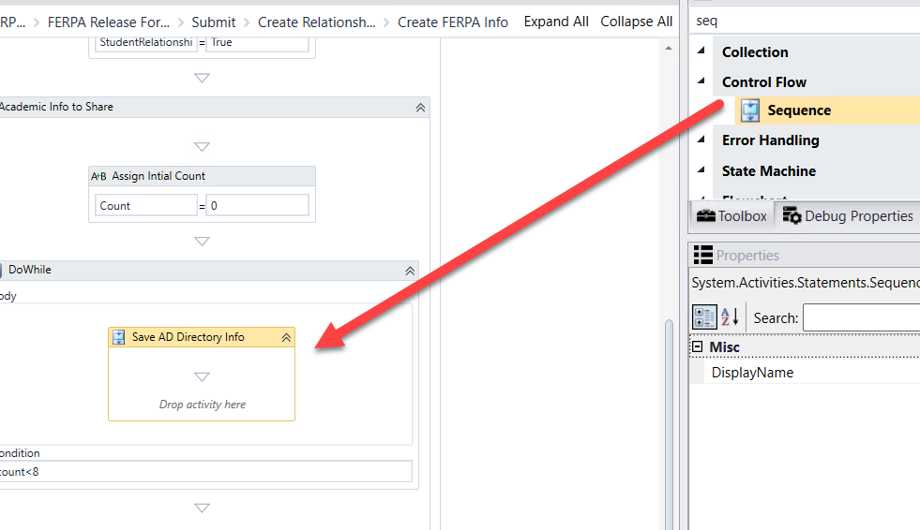

- Drag an If activity into the Save AD Directory Info Sequence activity.
- Rename the activity to: If selected, create
- Condition: mylist(Count)
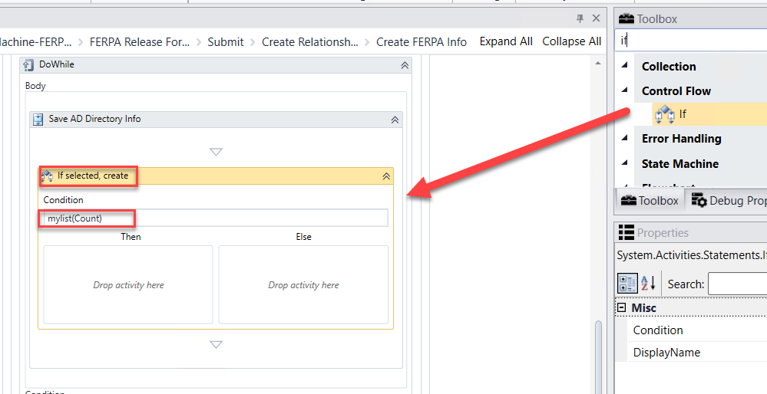

- Drag a Sequence activity into the Then portion of the If activity. Rename the activity to: Loop,create AD Directory
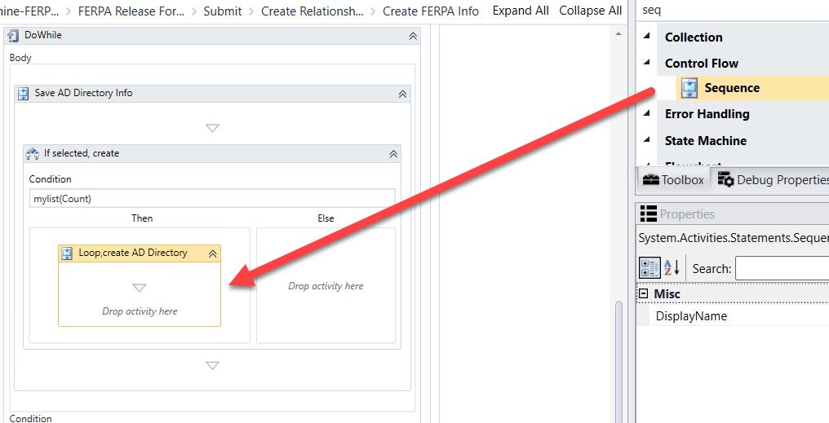

- Drag a CreateEntity activity in the Loop,create AD Directory Sequence activity.
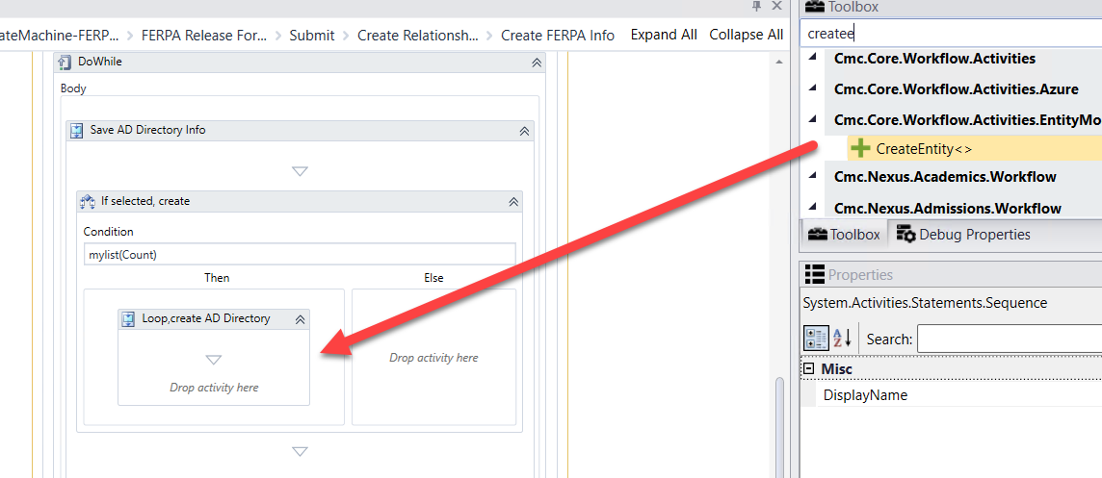

- Browse for Type: Cmc.Nexus.Crm.Contracts>Cmc.Nexus.Crm.Entities>FerpaStudentReleaseAcademicFieldEntity and Click OK

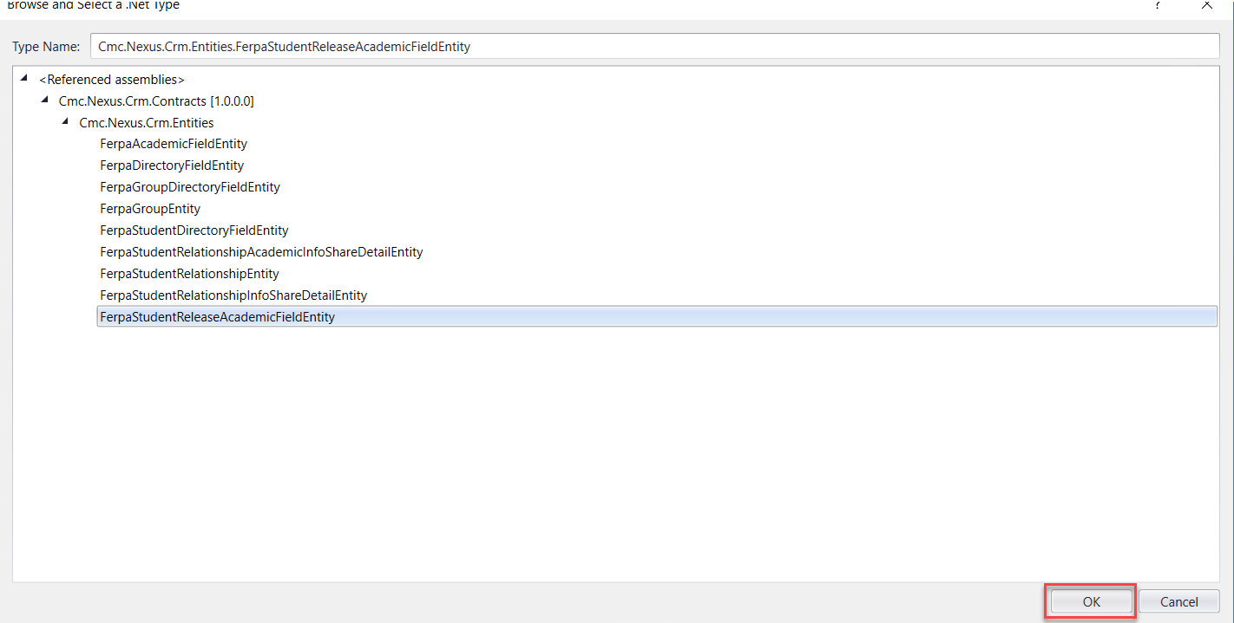

- Complete the properties as shown below.

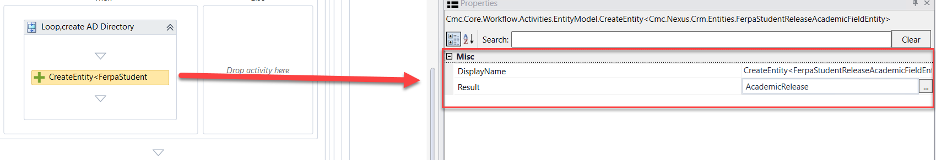

- Drag an Assign activity onto the Designer below the CreateEntity FerpaStudentReleaseAcademicFieldEntity activity. Update the properties as follows:
- Display Name: Assign Id; AcademicRelease.FerpaAcademicFieldId=count +1

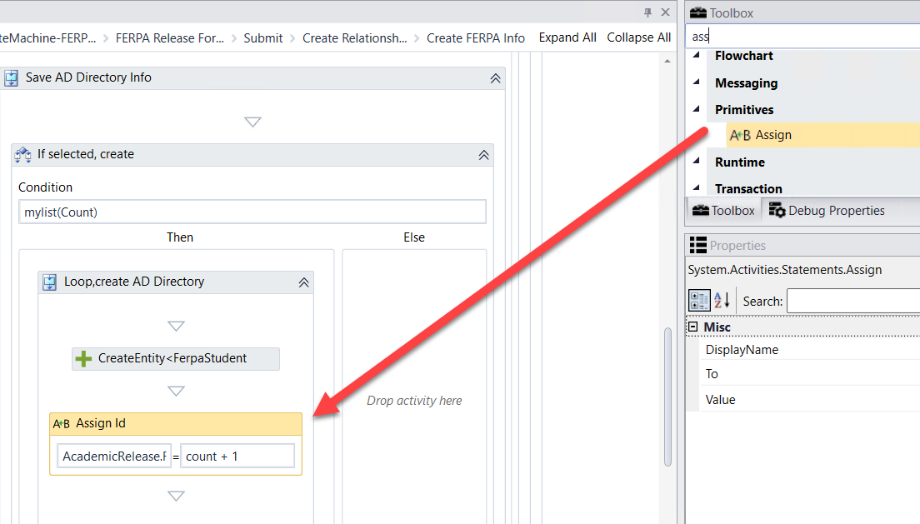

- Drag the AddToCollection activity below the Assign Id Assign activity.

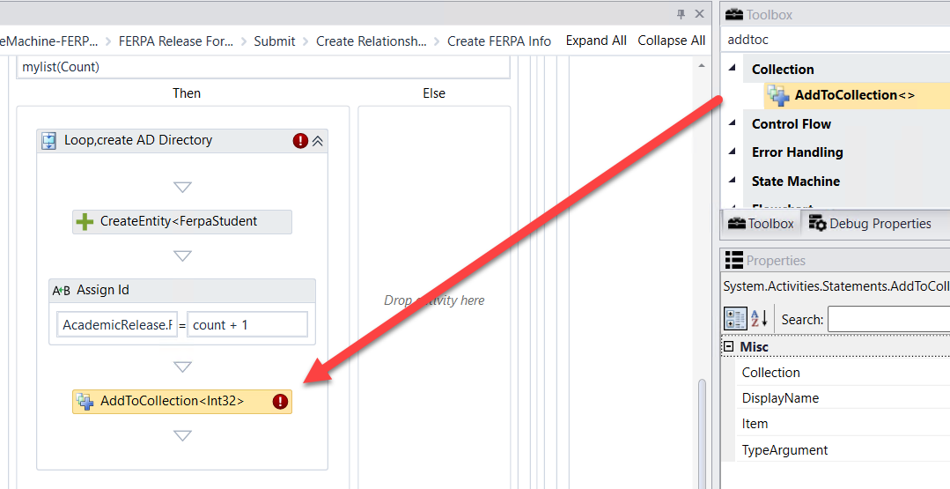

- Update the properties for the activity as shown below:
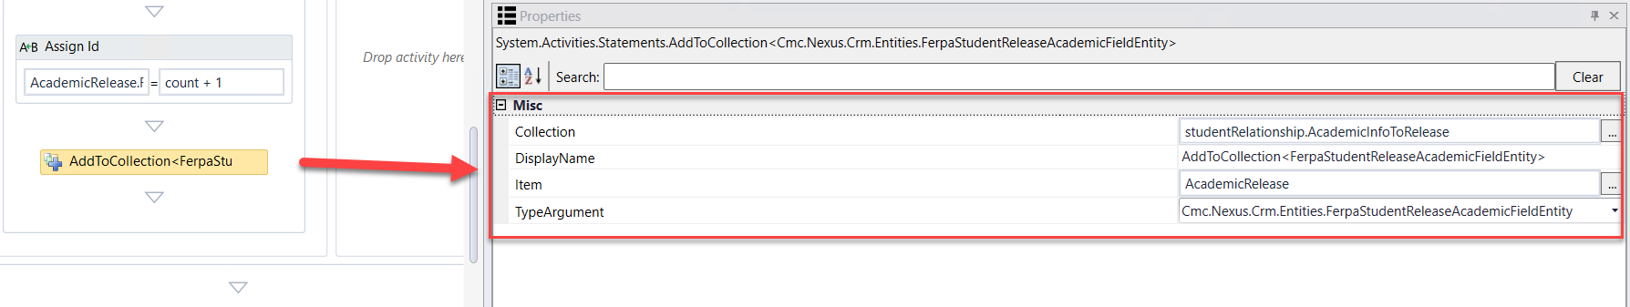

- Drag an Assign activity onto the Designer below the If selected, create If activity. Update the properties as follows:
- Display Name: Assign count increment; count=count +1

Note: Our count starts at 0 and we are going to increment 0 + 1 until we reach 8. This will create any of the 8 Id's based on the selection in the form.

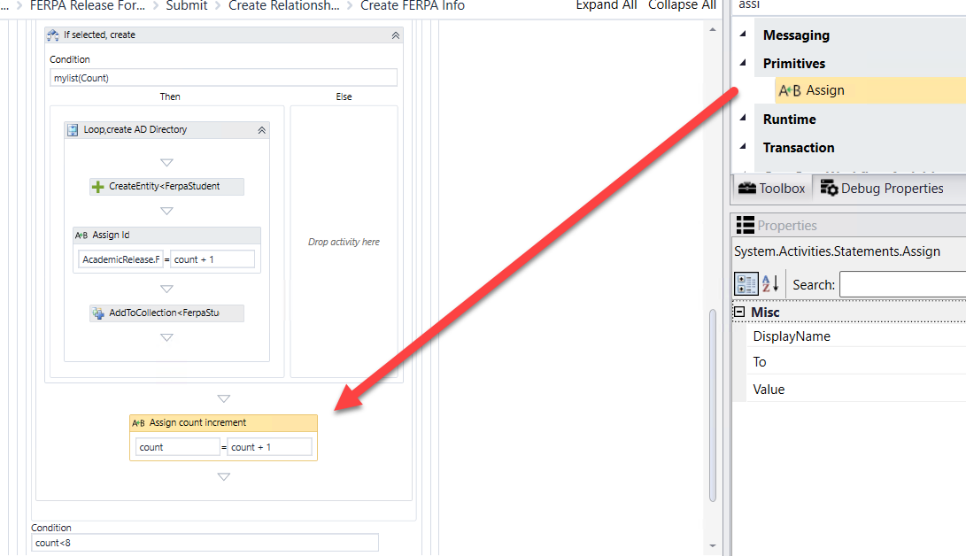

- Drag the LogObject activity below the Condition of the DoWhile activity. Update the properties for the activity as shown below:

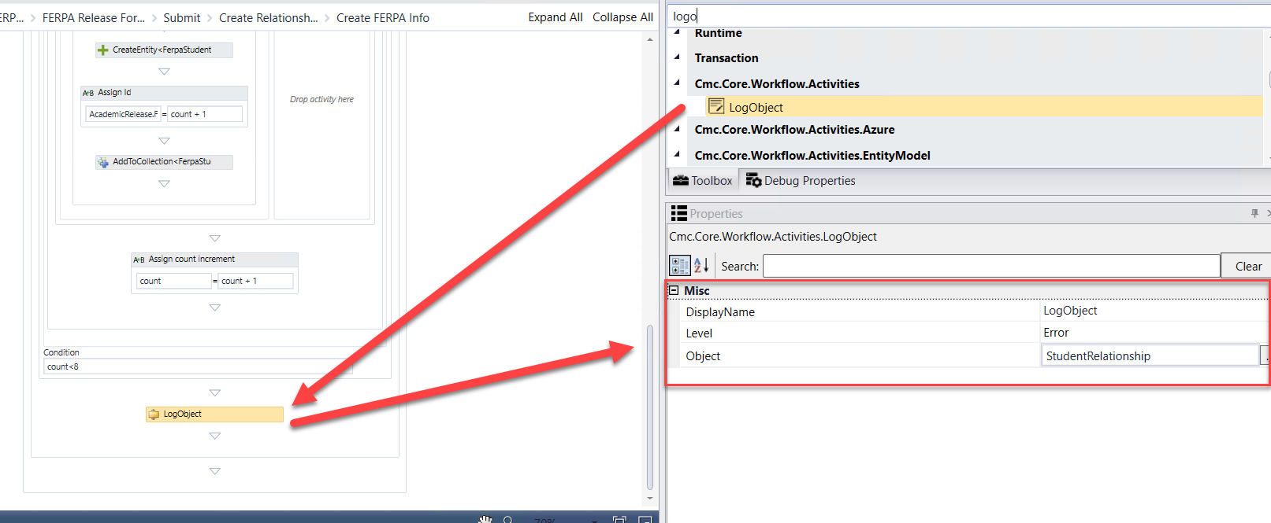

- Drag the SaveEntity activity below the LogObject activity.
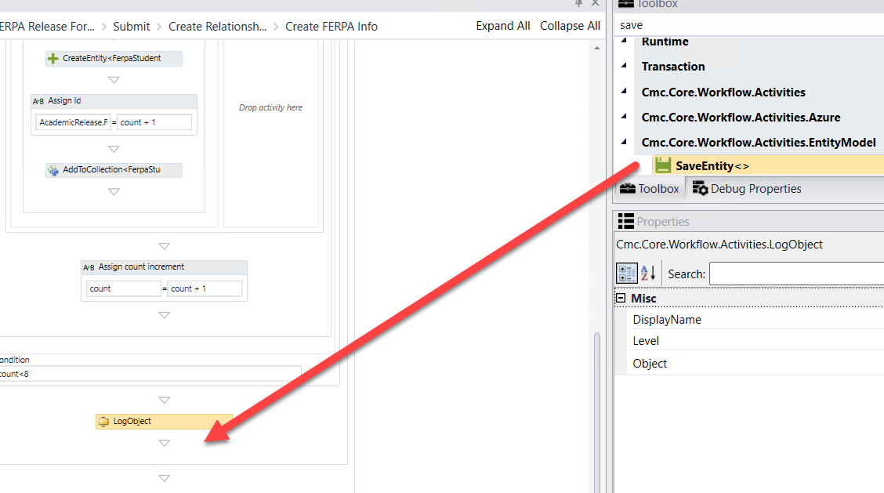

- Browse for Type: Cmc.Nexus.Crm.Contracts>Cmc.Nexus.Crm.Entities>FerpaStudentRelationshipEntity and Click OK

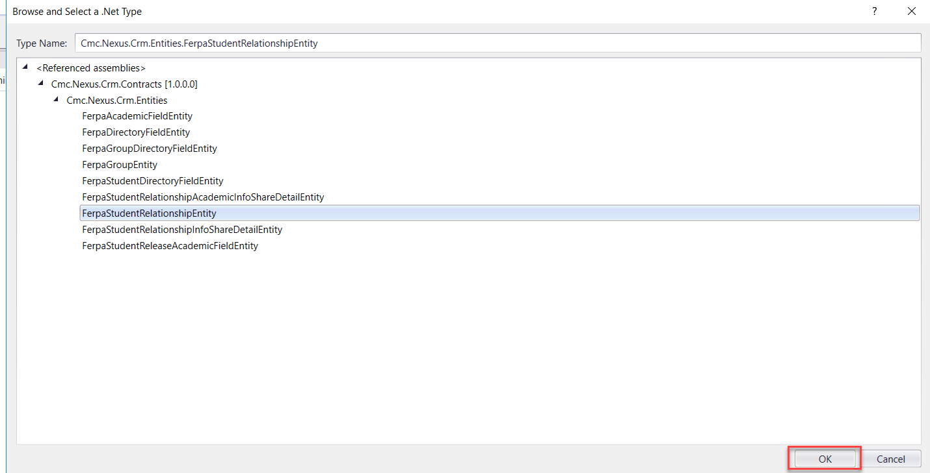
- Complete the properties as shown below.
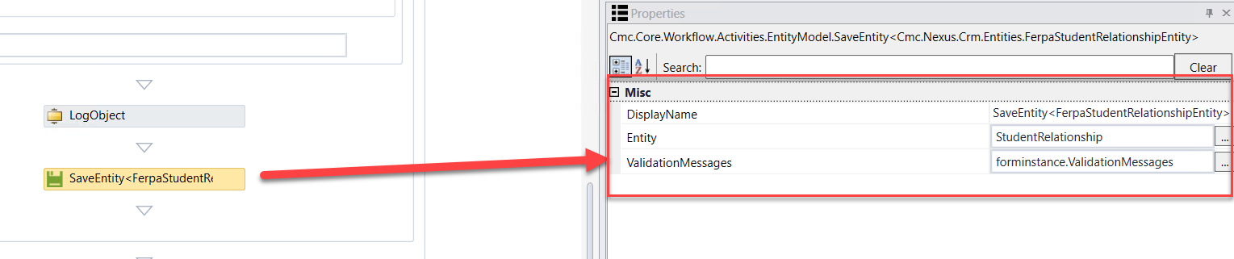

- Confirm there are no Errors in the Error pane.
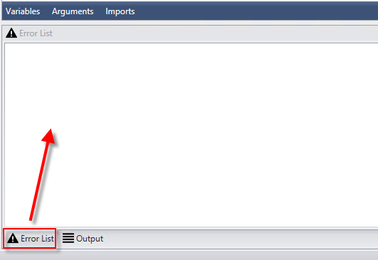

- Save your Workflow to: C:\CampusNexus\Insight2019
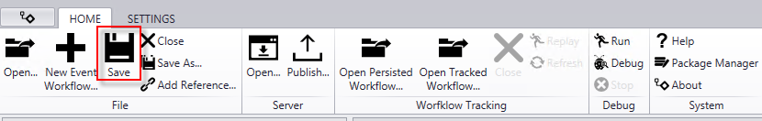

- Publish your Workflow. Make sure you select Enable This Workflow Version? and select Publish. Select OK to the confirmation.
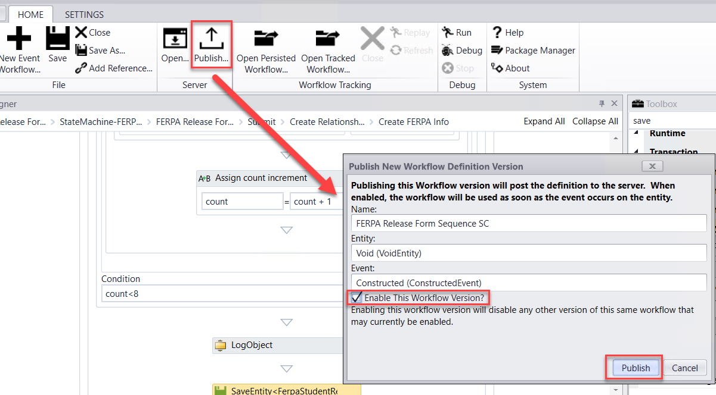

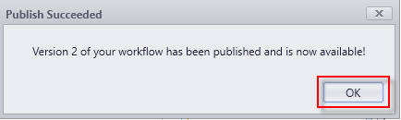

Lesson 2: Validate the Form and Supporting Workflow
In this lesson, you will validate the FERPA Process by logging in as a student and completing the FERPA Release Form Sequence. You will then validate the student record in the CampusNexus Web Client to ensure the correlating data was updated

Exercise: Validate the Student Self-Service Form and Supporting Workflow for the FERPA Process
- Navigate to Google Chrome and launch Student from the Bookmarks Bar.
- Sign in using the following credentials:
administrator
testing
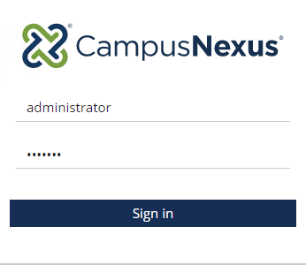

- Select Students.


- Search for student Anna Rizzo and click on the student link to open the student record.
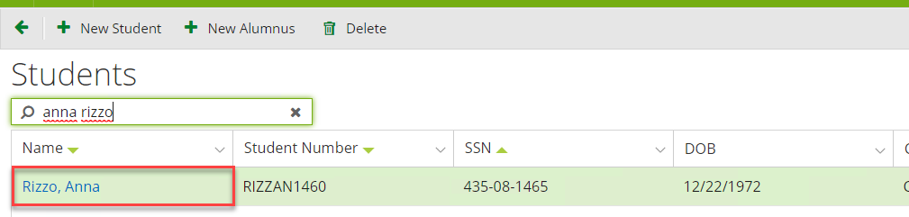

- Validate Data Block Indicator (FERPA) has not been selected for the student.
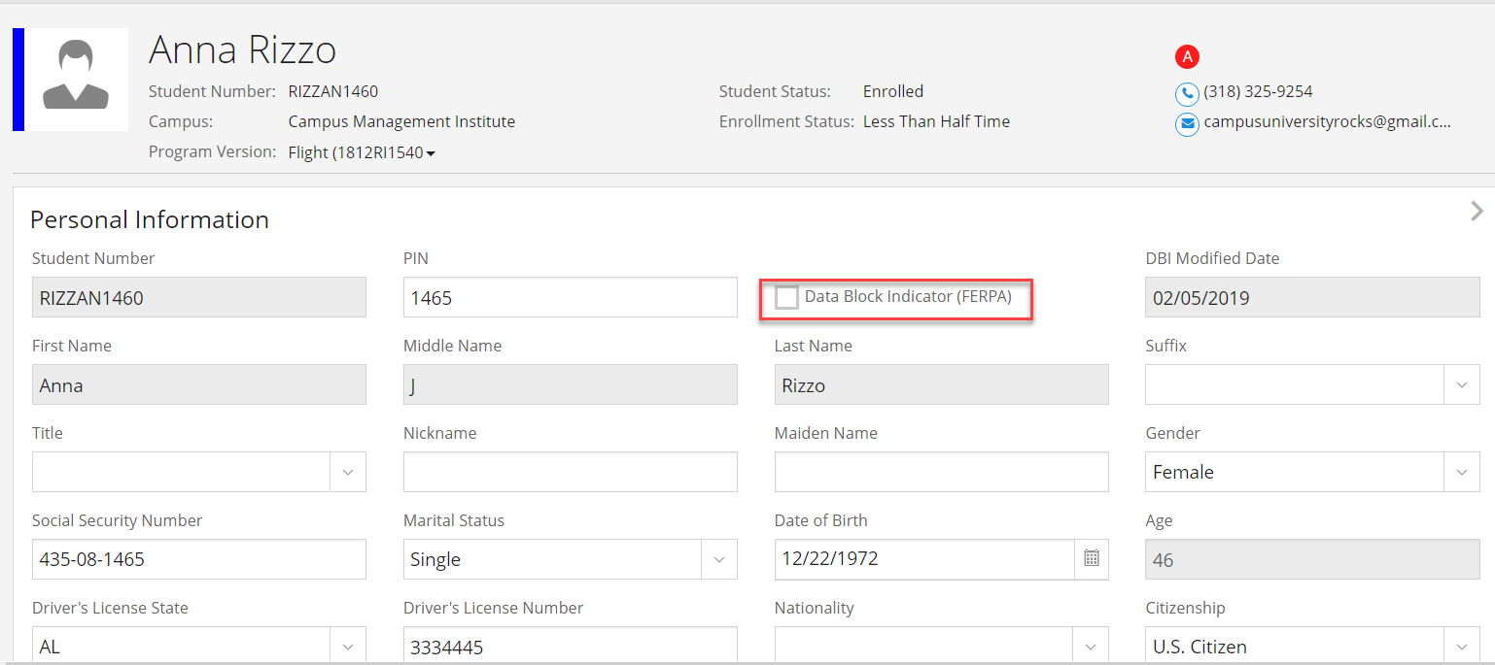

- Navigate to FERPA under Contact Manager. Validate no FERPA information is added for the student.
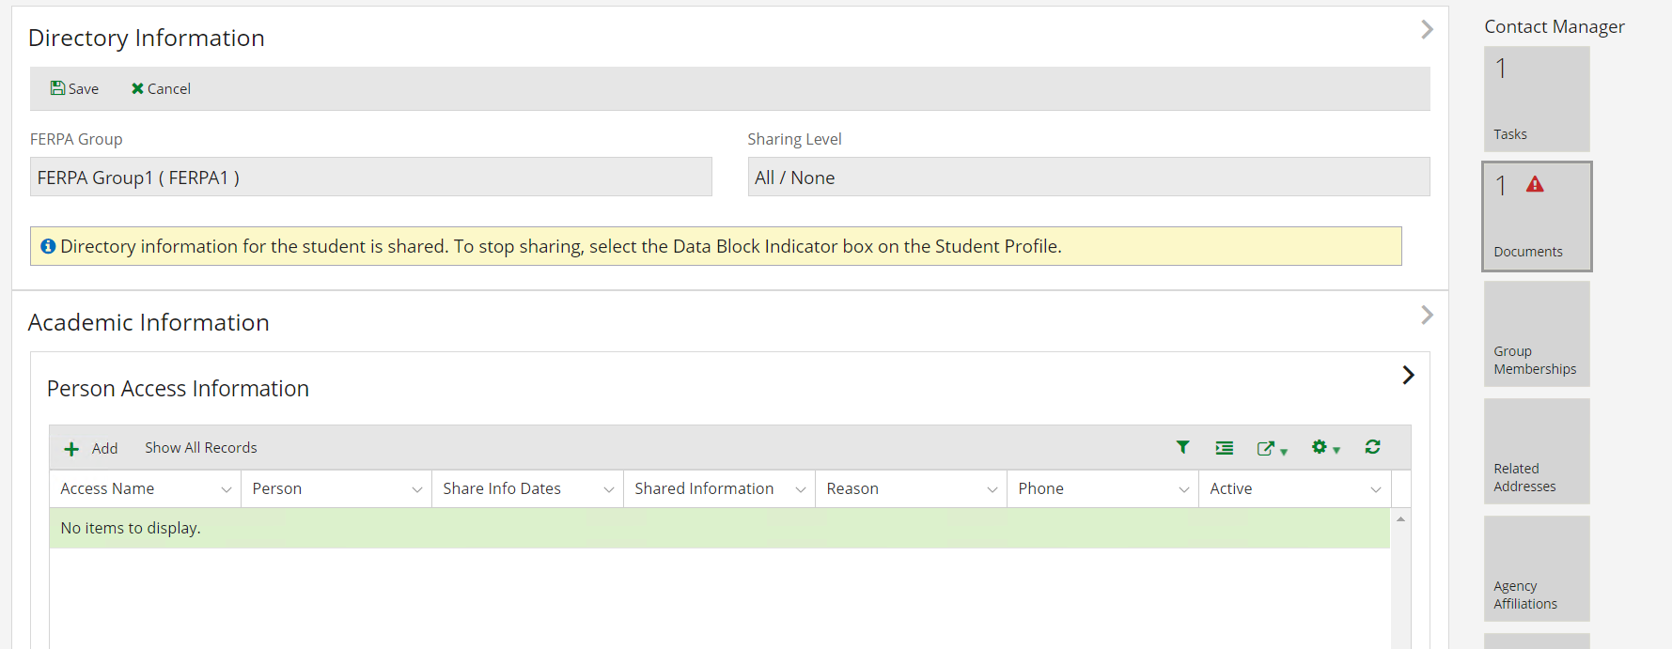

- Open Google Chrome and launch Renderer from the Bookmarks Bar.
- Find your FERPA Release Form Sequence in the list and click the arrow to navigate to the sequence.
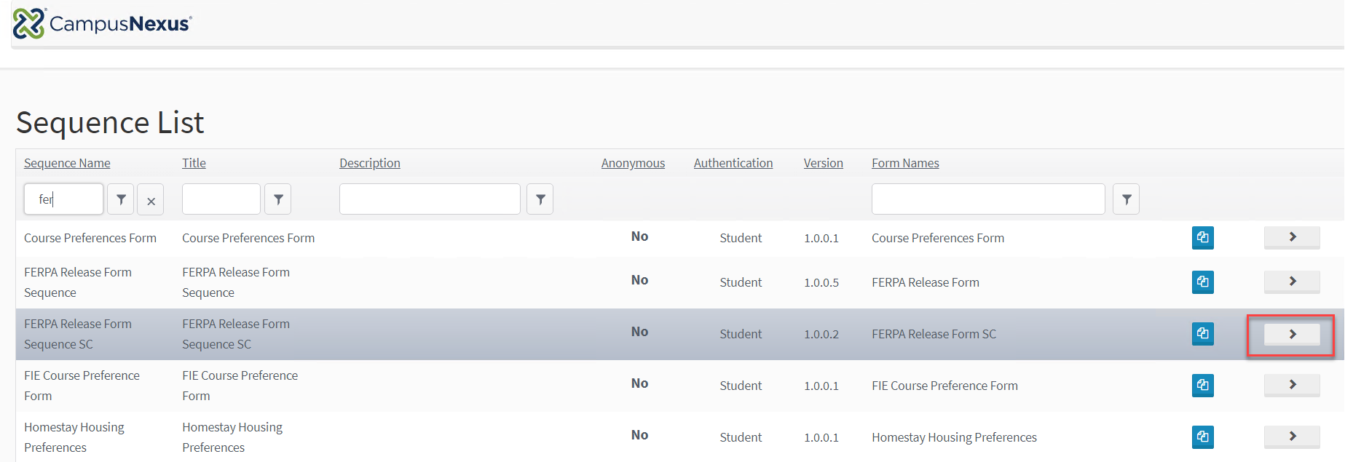

- Login as the student:
Username: anna.rizzo
Password: nexus123
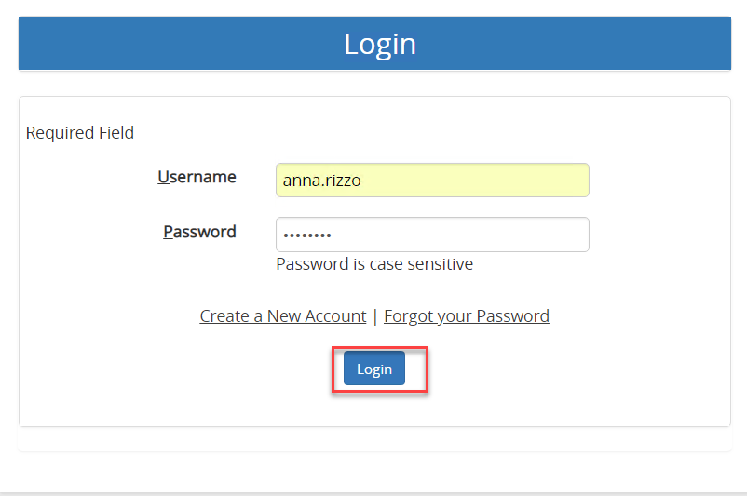

- Complete the FERPA Release Form as shown below:
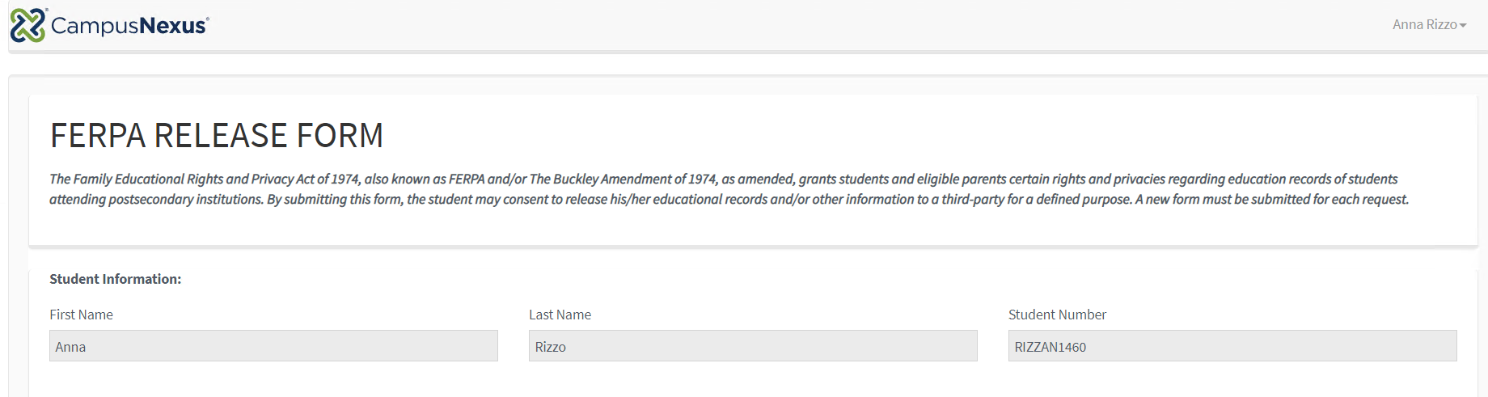
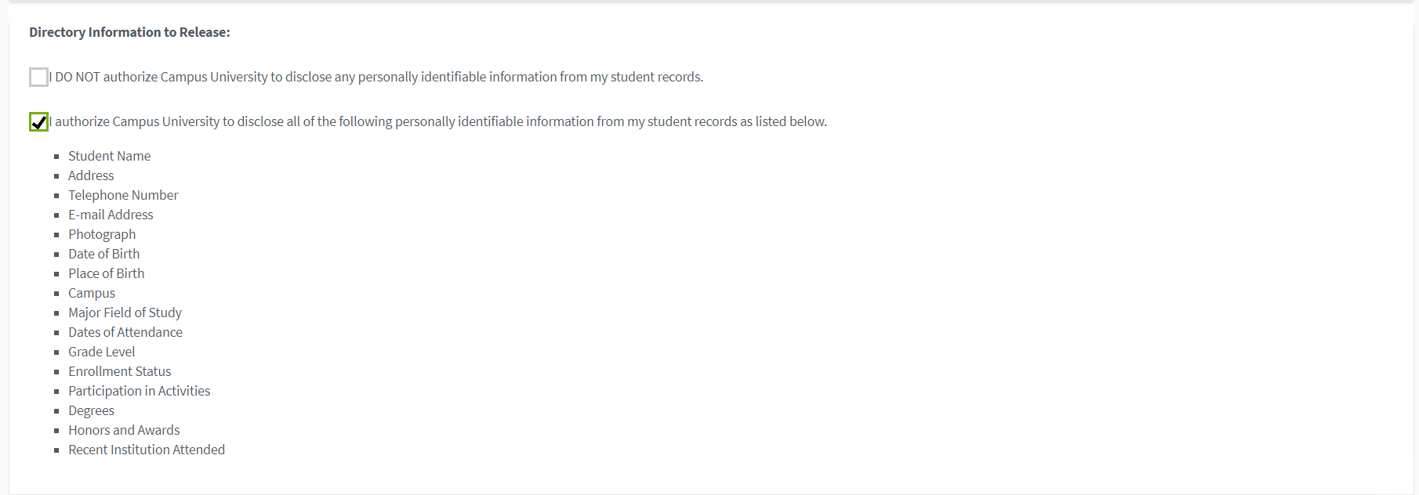
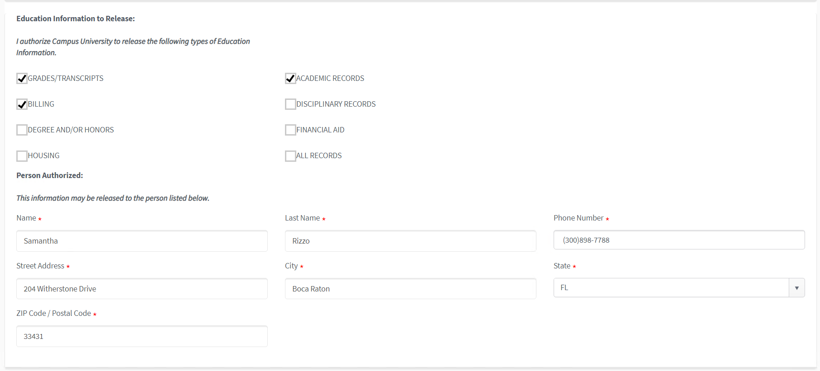

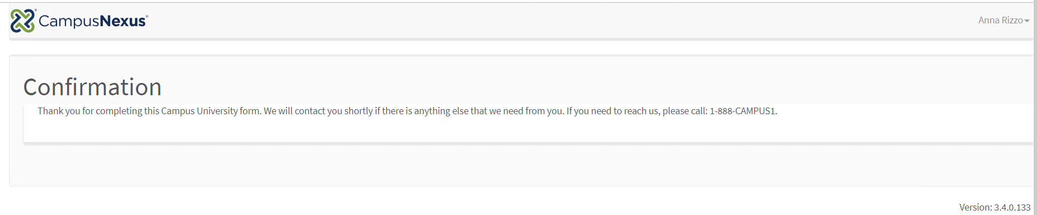

- Navigate back to CampusNexus Student and verify the Data Block Indicator (FERPA) is now checked and the FERPA icon is displayed on the student record.

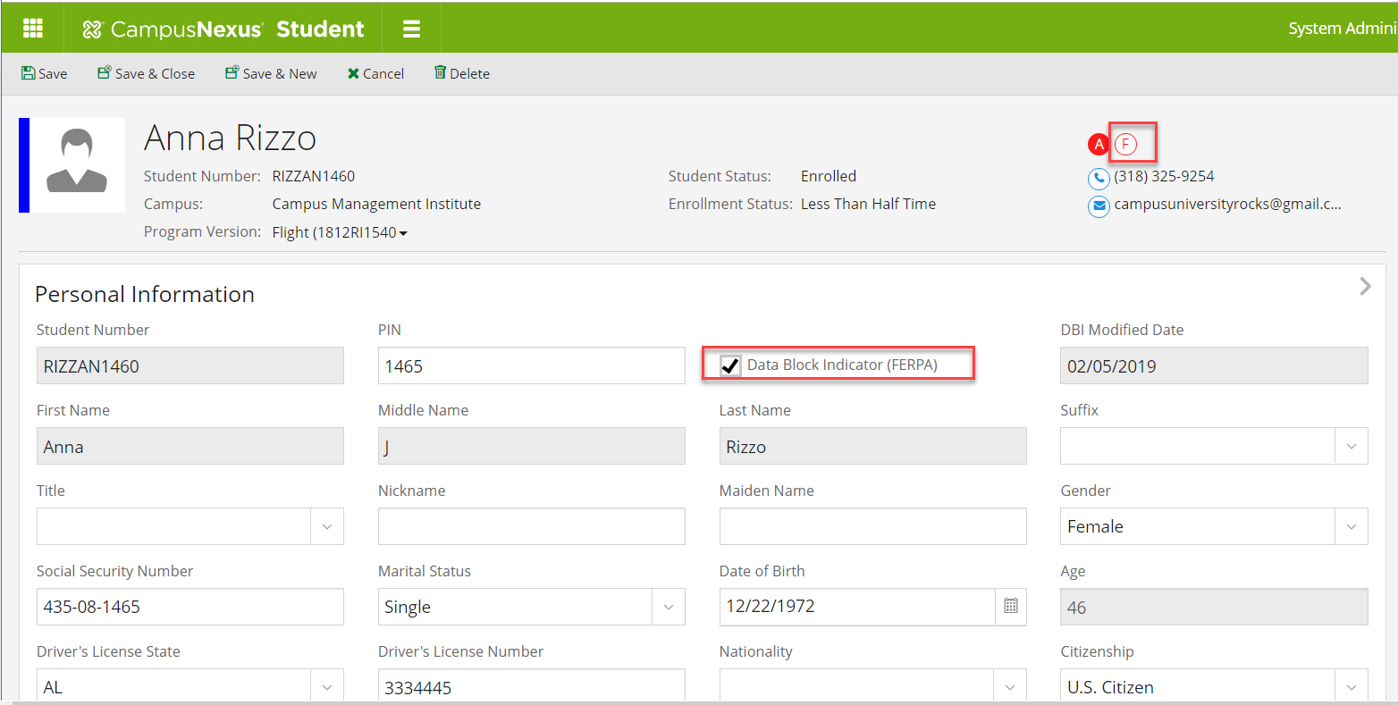

- Navigate to FERPA under Contact Manager. Validate FERPA information is added for the student.

